### Interview preparation-1

**sumanAppala**

[**asuman312@gmail.com**](mailto:asuman312@gmail.com)

**9963539229**

**1. General Questions**

1**.1. Tell me about yourself?**

   Thanks for giving opportunity to introduce my self,This is suman appala I completed my graduation in 2012 in kakatiya university warangal. I had total 8 years of experience which include 4.1 years in salesforce, rest of 4 years i had worked on Sap functional consultant

**1.2. Explain your IT and Salesforce Journey?**

My journey in IT and Salesforce has been quite exciting and filled with learning opportunities. It all started with my fascination for technology and the desire to understand how systems work and how they can be optimized to improve various processes.I began my IT journey by learning Administration, which laid a strong foundation for my understanding of development and database management. I also delved into development, mastering Apex,Triggers ,Asynchronous Operations, Test classes

**1.3. Which clouds, you have worked in Salesforce?**

I had experience in sales cloud and service cloud

**1.4. What is your Notice Period?**

30days

**1.5. Are you a contract or permanent employee?**

Permanent employee company staff

**1.6. What is your current CTC?**

 7LPA

**1.7. Is your Current CTC Fixed or Variable?**

Fixed

**1.8. What is your monthly take-home?**

51000

**1.9. What is your Expected Salary?**

My expected salary is 12 LPA.

**2. Project Questions**

**2.1. How many Salesforce Projects you have worked on?**

 I was worked on 3 projects

**2.2. Explain your current Salesforce Project Descriptions from end to end?**

Hetero Drugs is a health portal which provides services related to COVID-19 or general decease. Patient can register in the community portal and take a survey regarding the decease. Based on the result, the patient needs to make payment on the community payment and register their appointment. The doctor can view the patient history and the related appointment on salesforce and create a case. All the history of the patient can be viewed on Salesforce by the doctor.

**2.3. What is your Role and Responsibilities in your current Project?**

Going through the use case documents, understanding and analyzing the requirements.Verifying all the validations of the application.Verifying the survey responses, payments, and appointment creation on community.Verifying that doctor can create a case to the respective patient. Involved in administration tasks like custom objects, fields,flows,page layout,approval process.

**2.4. What are your day-to-day activities in your current Project?**

Going through the use case documents, understanding and analyzing the requirements

**2.5. Which clients and client locations have you worked for?**

Hyderabad,I was not worked on client location

**2.6. What is your current/recent work in your Salesforce Project?**

The Quest Oracle Community is dedicated to helping Oracle users develop skills and expand knowledge by connecting with other Oracle users and experts for education and networking. Non-profit organizations governed by a volunteer board of Oracle customers who understand and are committed to the power of Oracle users helping other users move their businesses forward.

**2.7. What are your strengths and weaknesses while working on Salesforce Projects?**

My greatest strength is to accepting the new tasks and my weakness is I will put more concentration on single work at a time

**2.8. What are the different challenges you faced while working on Salesforce Projects?**

**2.9. What is your team size?**

20

**3. Admin Questions**

**3.1. What is a recent admin scenario you have worked on?**

Customization, configuration on Data modeling

**3.2. What are the Functionalities you have worked in Admin?**

Resolve user support tickets, Identify and gather requirements from users and stakeholders,users and license management roles,profile, permission sets

**3.3. Create Custom Objects: Define essential custom objects like Patients,**

**Appointments, Doctors, and Medical Records in Salesforce.**

In order to create custom object for above these objects we have follow some steps

Go to set up click on object manager

Click on create and fill the custom object information

Click on create a tab also

 In next step enter tab details

Add to profiles

Add custom apps

Click on save

**Patient Object:**

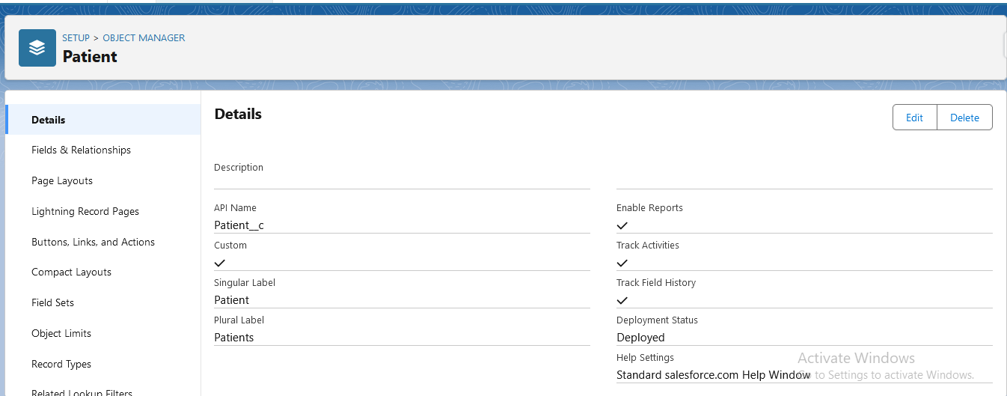

**Appointments:**

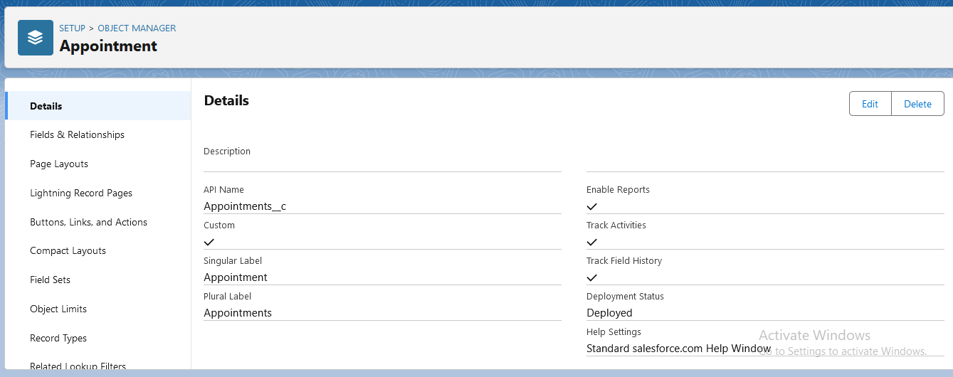

**Doctor Object:**

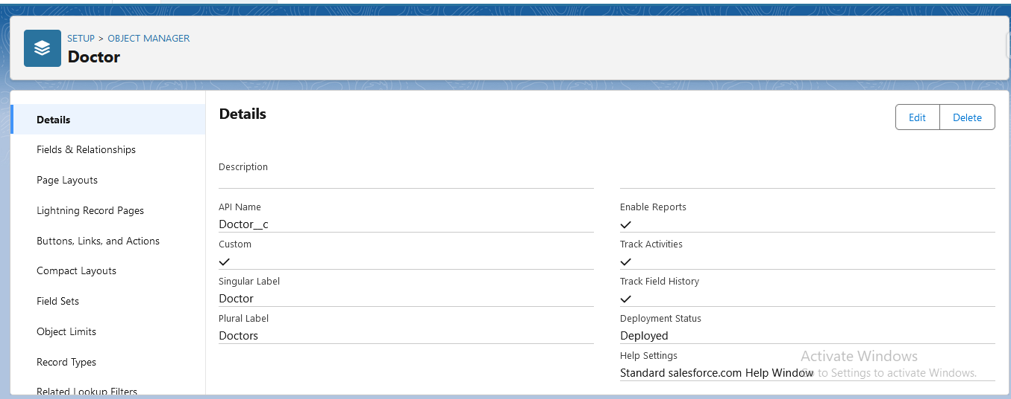

**Medical Records:**

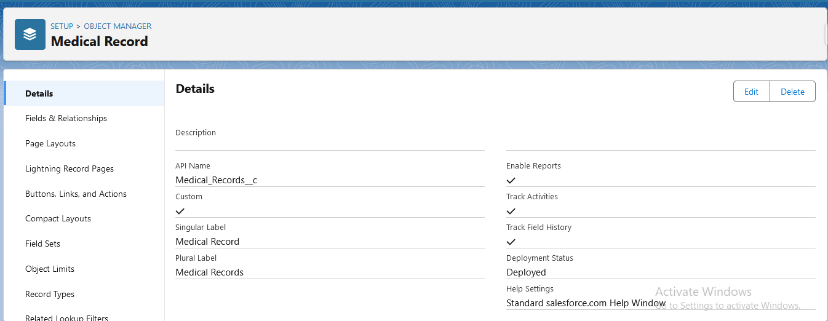

**3.4. Establish Object Relationships: Set up relationships between these custom**

**objects (e.g., Patient-Appointment, Patient-Medical Records) to establish**

**connections and data flow.**

For Patient & Appointment, here Appointments are associated with a specific patient. Each appointment is tied to a particular patient.

Patient------- ------- (Parent Object) Can have multiple appointments.

Appointment------ (Child Object) Belongs to one specific patient.

For patient & medical records, here Each of medical records belongs to one patient.

Patient -------------- (Parent Object):  Has one or multiple sets of medical records.

Medical Records---(Child Object): Belong to one specific patient.

**Master Detail relationship: Patient-Appointment**

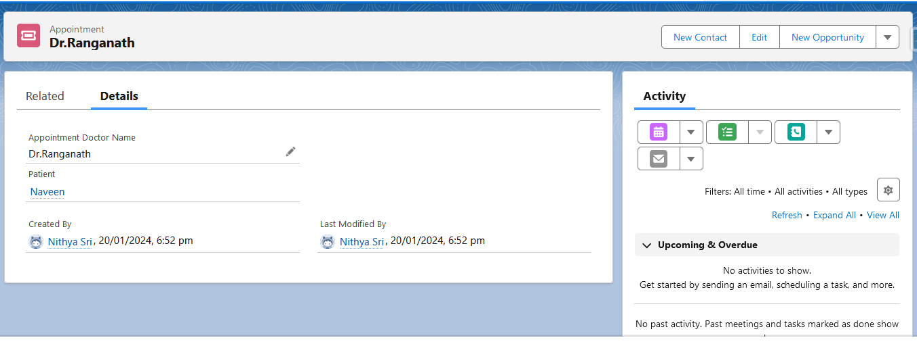

**Lookup Relationship:  Patient-Medical Records**

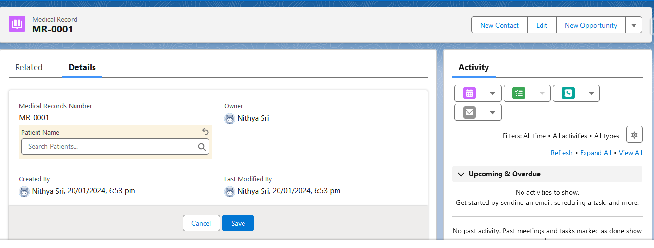

**Graphical view of 3 Objects relationship:**

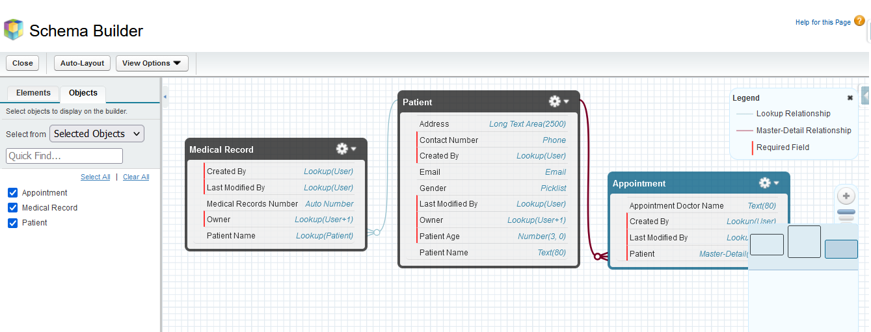

**3.5. Design Data Model: Plan and implement a basic data model outlining the**

**fields required for each object, considering essential patient information,**

**medical history, appointment details, etc.**

Go to setup Choose the object on which object you want to create fields click on fields & relationships click on new choose the data type enter the details, establish field level security add to page layout click on save. We can make fields are required

**Patient information:**

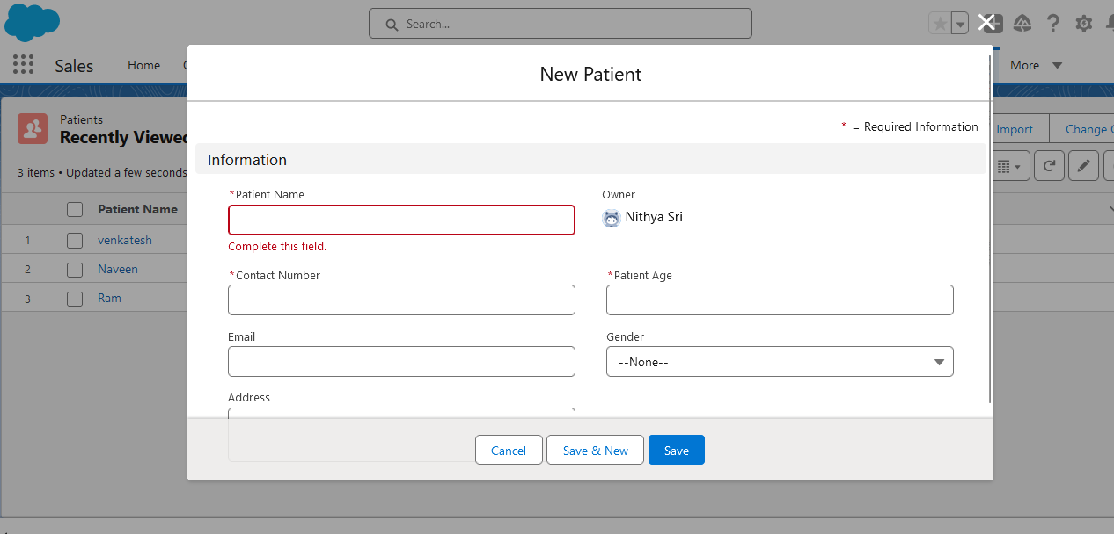

**Medical History:**

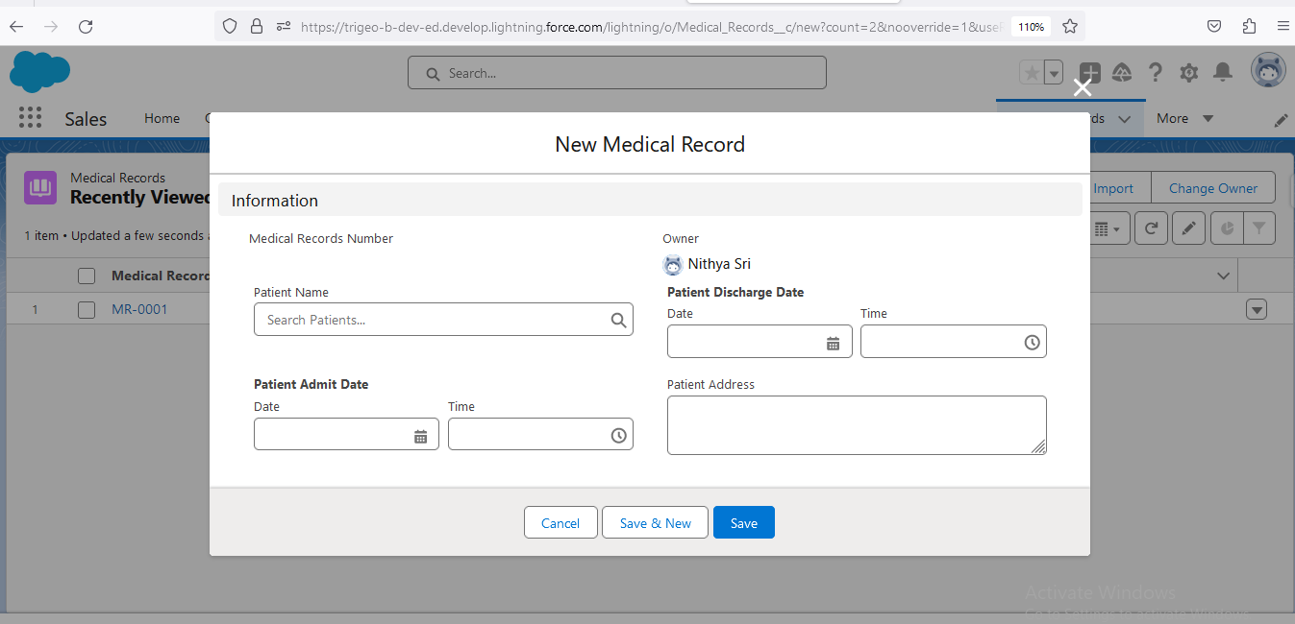

**3.6. Data Entry and Testing: Input sample patient data into the system to test the functionality of the created objects and relationships.**

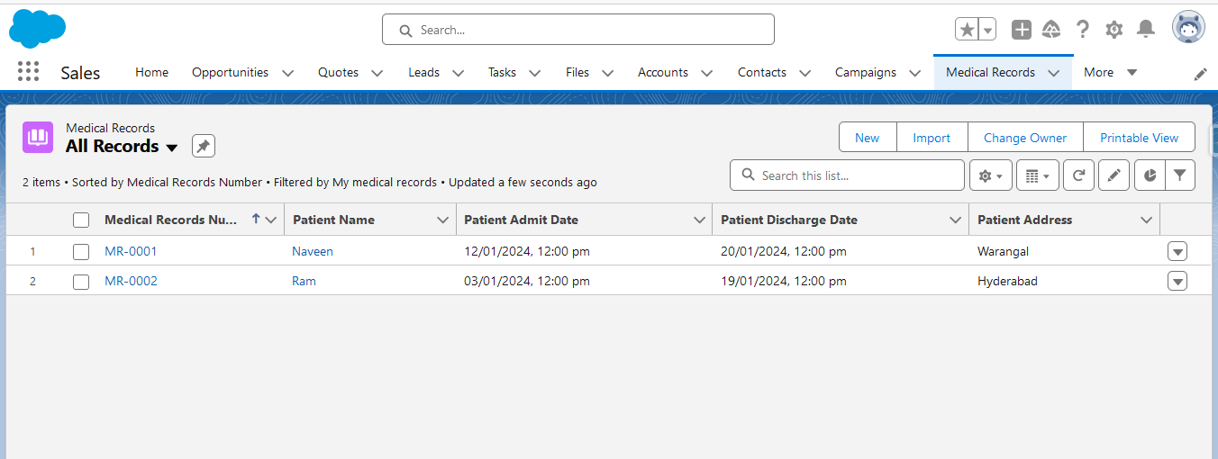

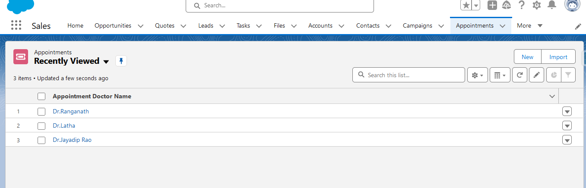

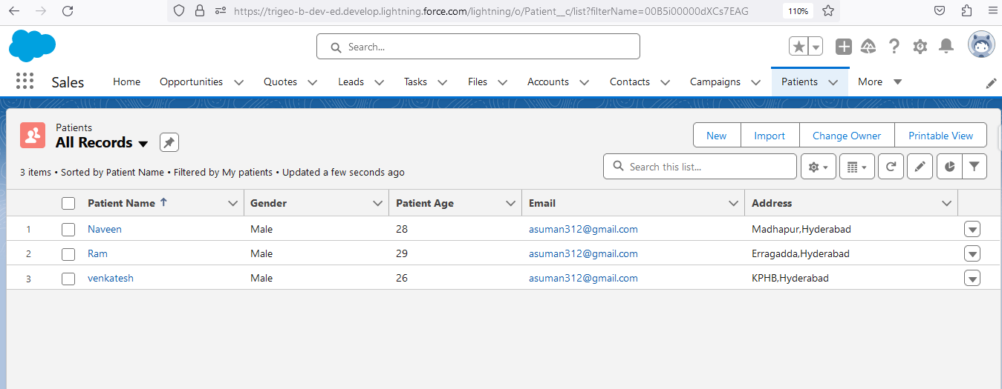

**3.7. Implement Basic Security Measures: Set up initial security settings like defining user roles, profiles, and permission sets to control access to patient information based on user roles.**

1. **created a profile As Gandhi hospital**

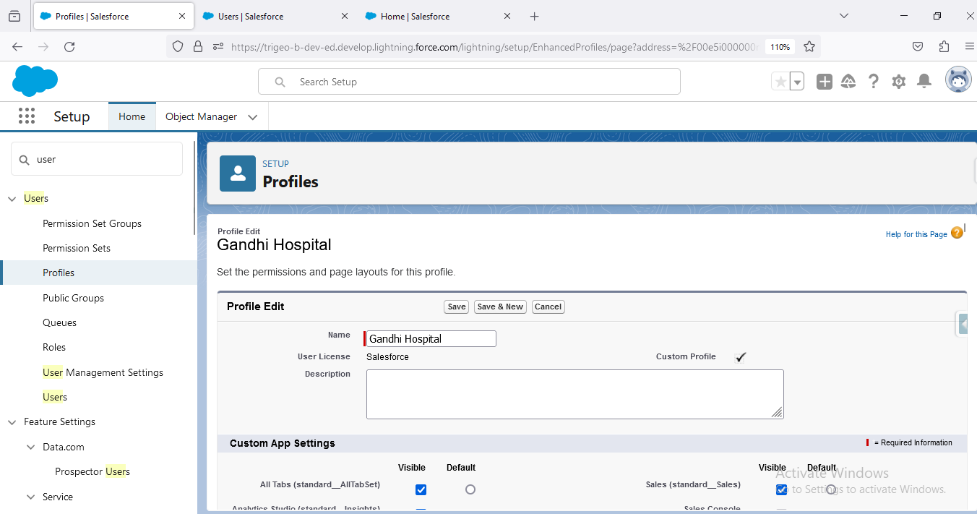

1. **Created a User & Assigned to Gandhi Hospital Profile**

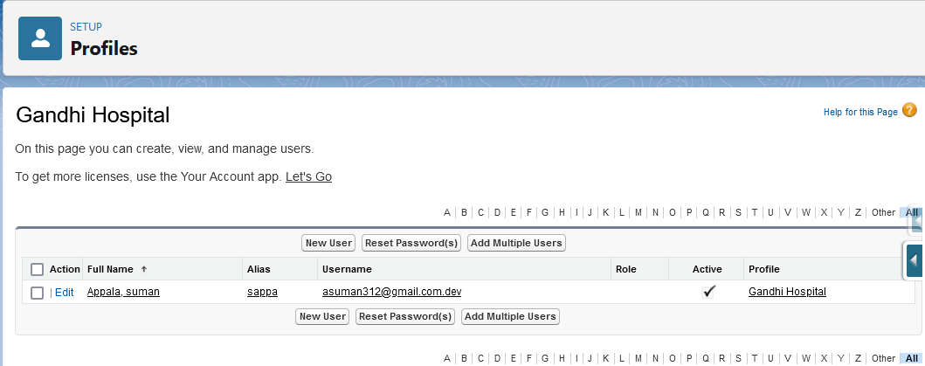

1. **In Profile Custom Object Settings, I hidden patient Object to User (Suman)**

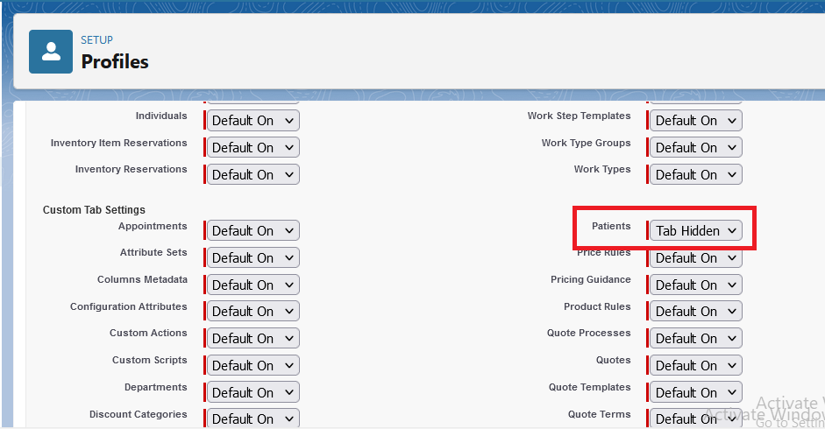

1. **Now logged in as suman Appala He is not Able to see Patient Object Tab and also  AppLauncher**

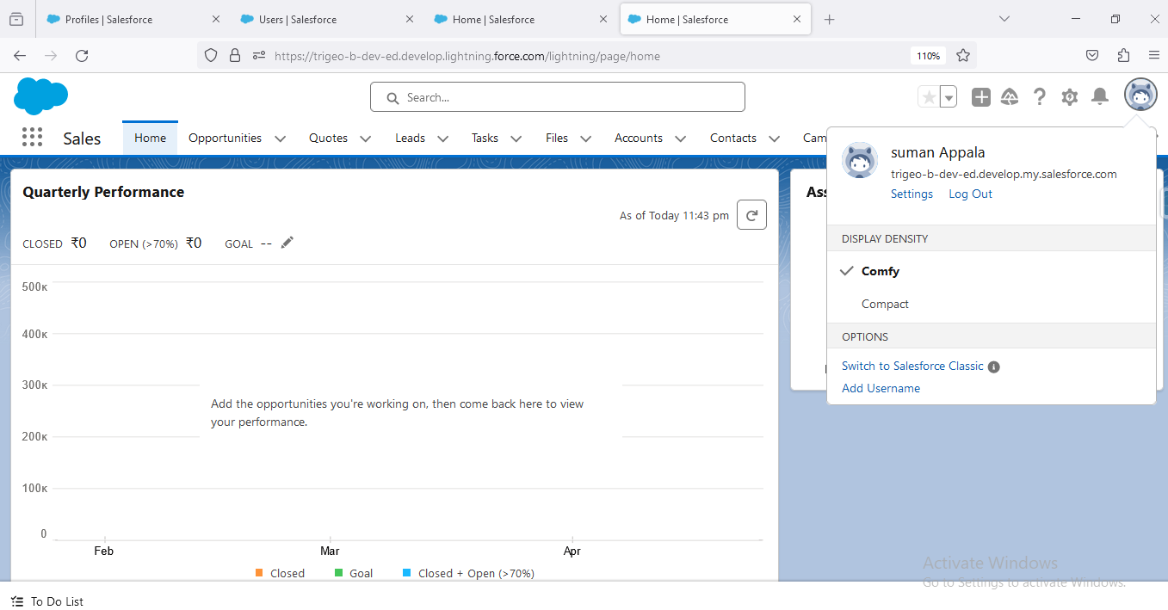

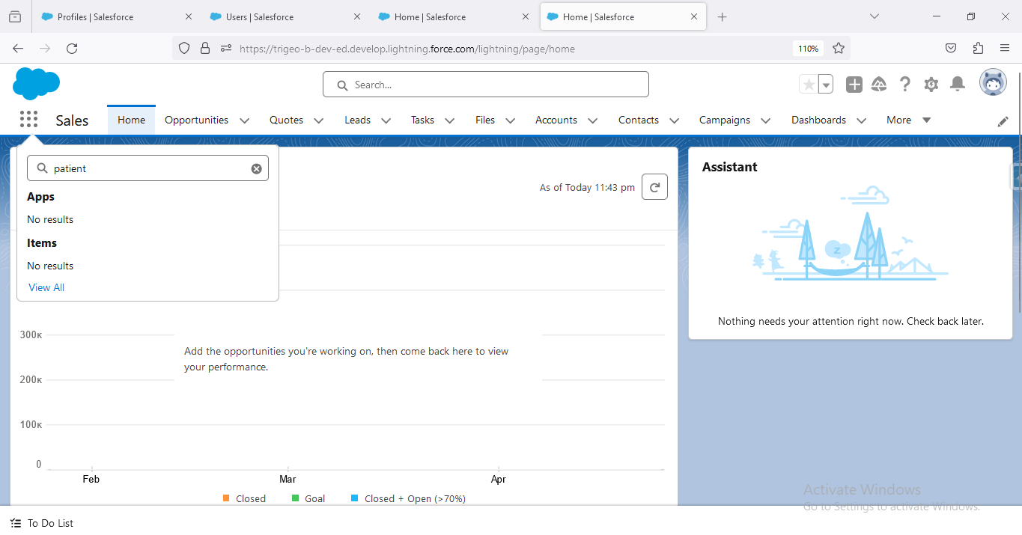

**Create a permission sets to control access to patient**

**information based on user roles.**

1. **i Created a permission set for Patient and Assigned a user(Neethu)**

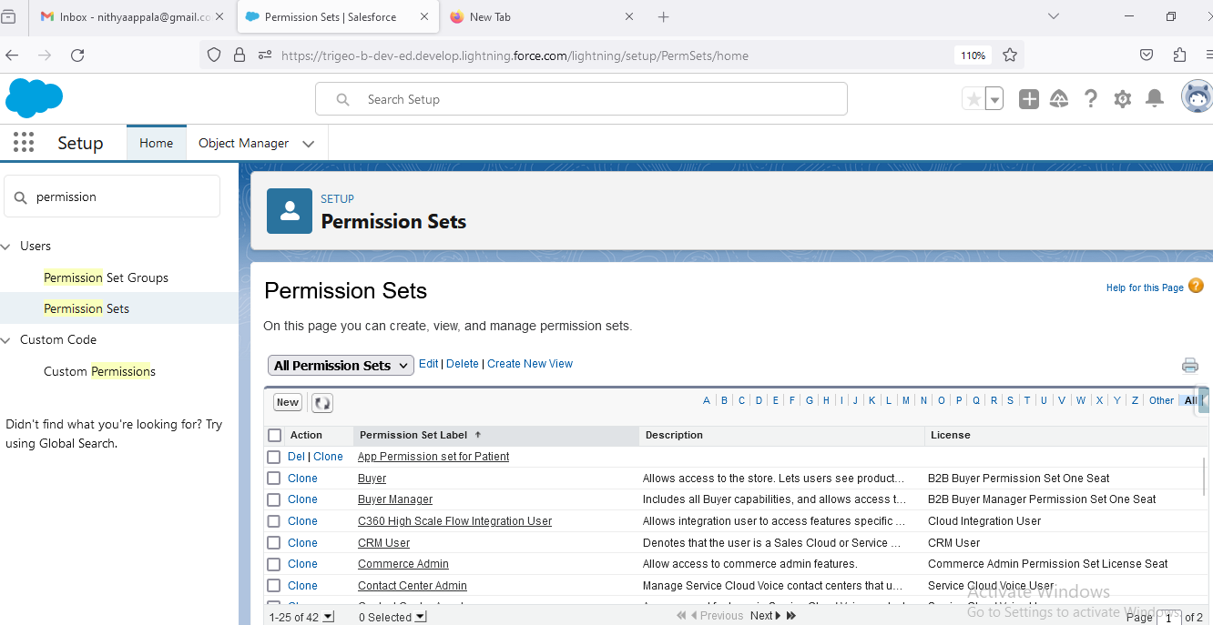

1. **I assigned object permission set to to user as read only**

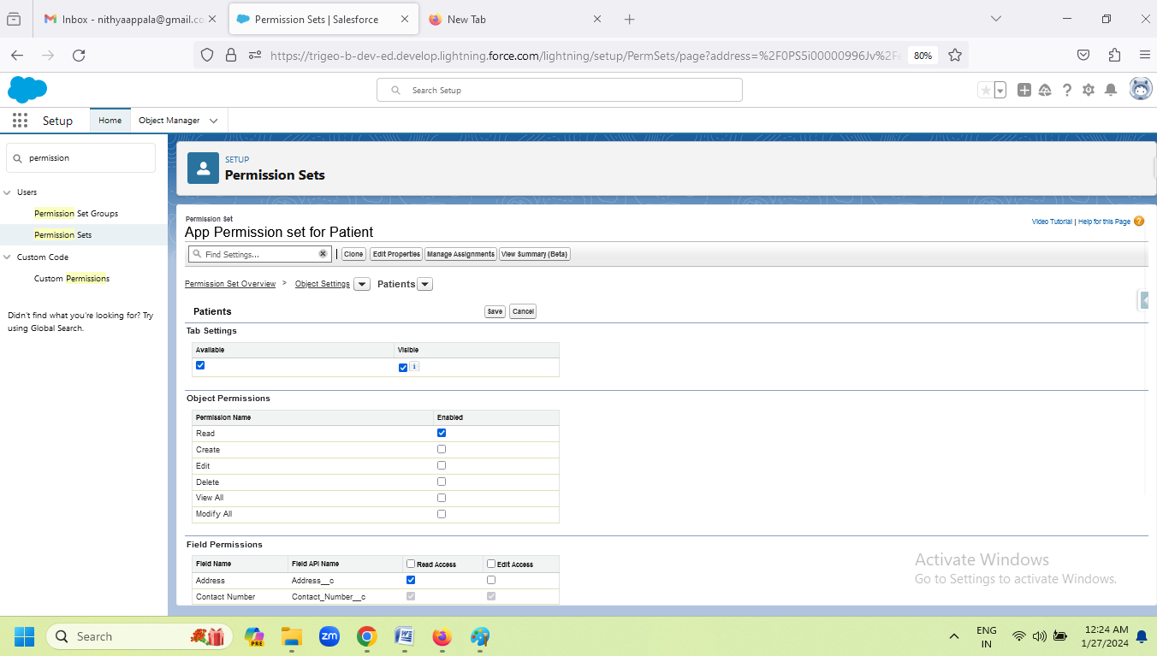

1. **Now I am logged into user(neethu) able to see the Patient Object but Cannot edit Because i gave the permission set as read only**

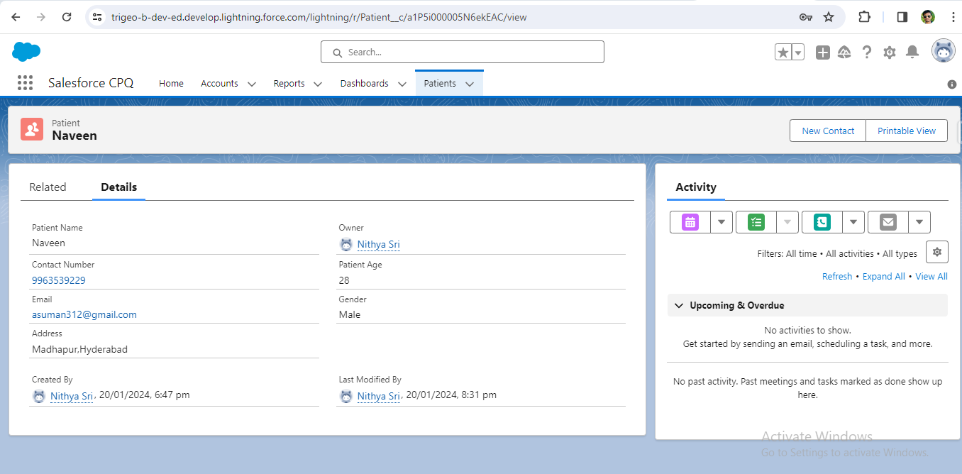

**3.8. Prototype Automated Notifications: Set up basic automated notifications, such as appointment reminders or alerts for new appointments, using simple workflows or process builders.**

First off all Workflows and process builder is retire soon salesforce officially recommend to use the flow builder

Workflow rules used to automate business process and it is associated with object

The requirement is when appoint is created immediately send email notification to user

Go to work flow click on create select the object as appointment click on next configure workflow rule

Mention criteria email not equal to null click on done then add action select email alert select the email template and select user click on save when appoint is created automatically email notification go to the assigned user

**A .created a workflow rule on Appointment**

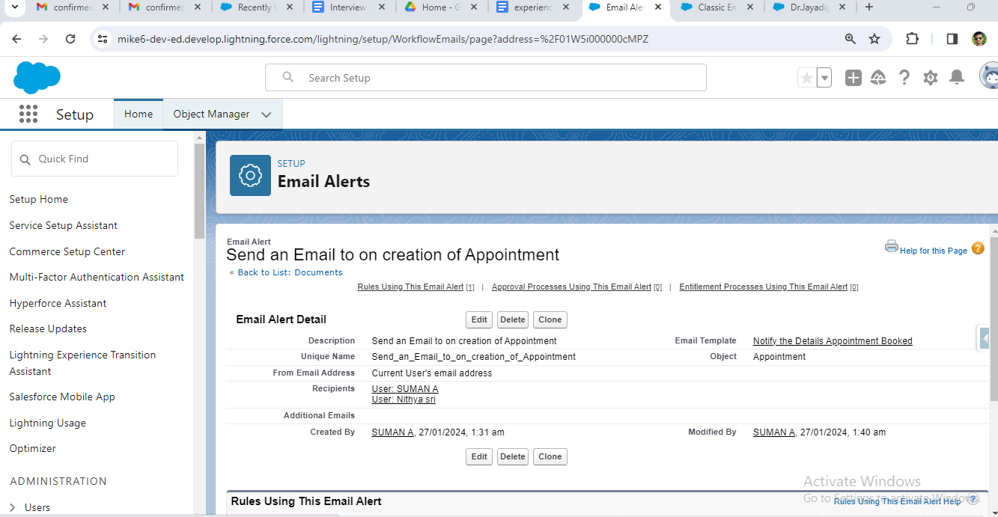

**B.Created a Email Alert on workflow rule by using Email Template**

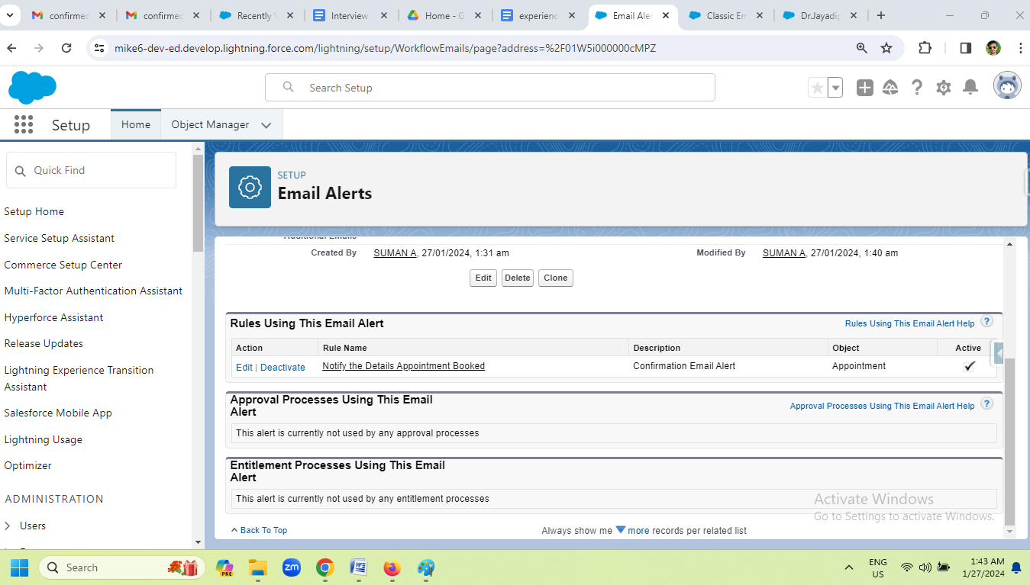

**C. Created A one record on Appointment Object**

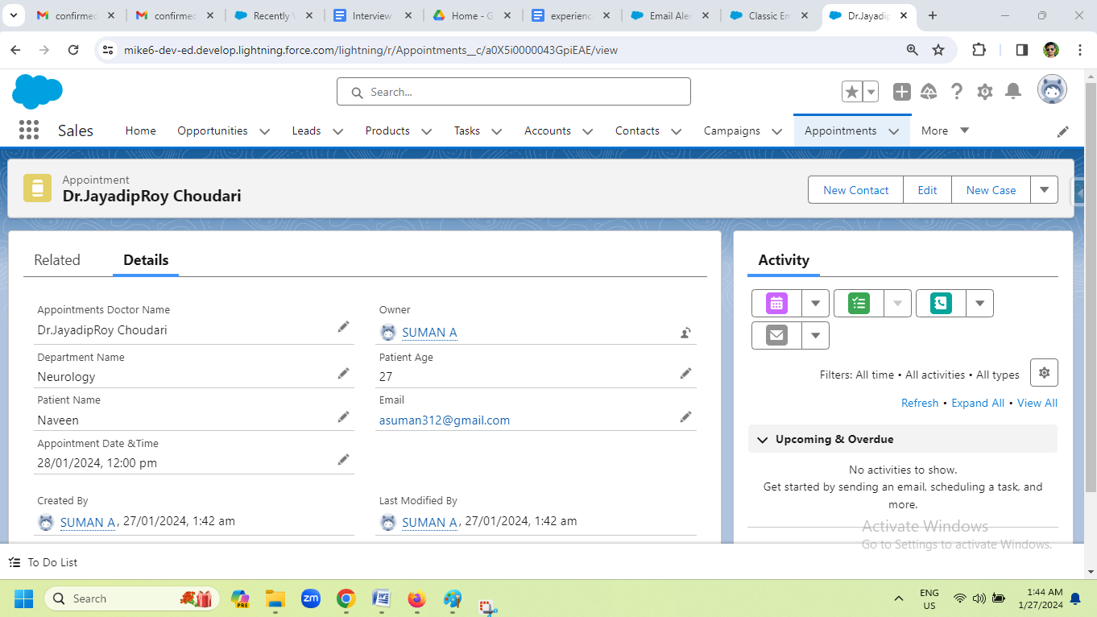

1. **Finally Received a Confirmation Email For Appoint Booked**

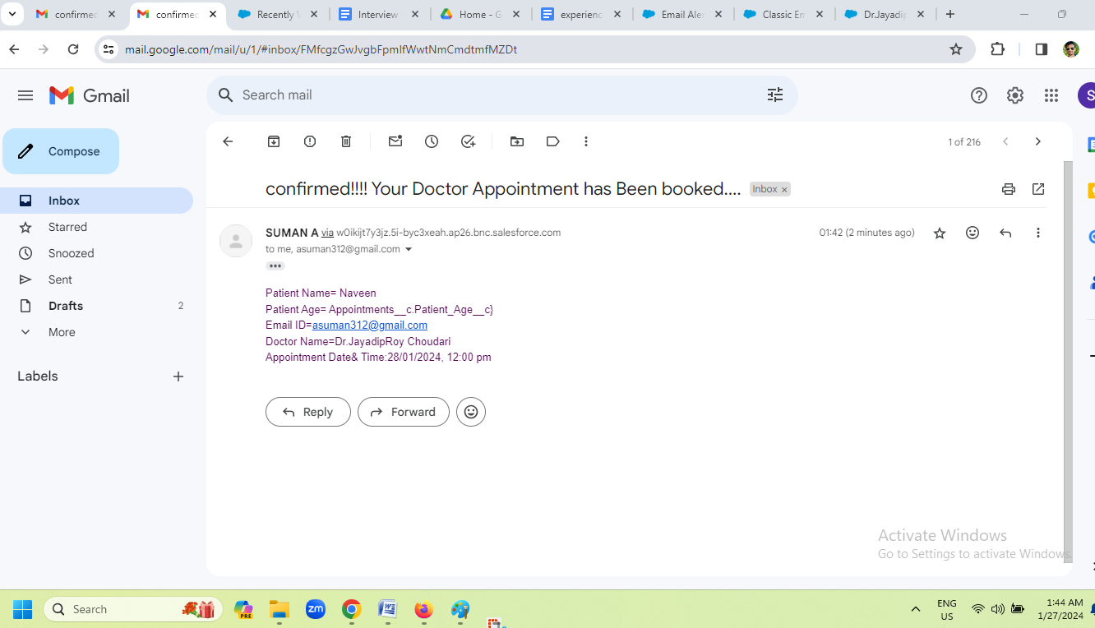

**4. Apex, SOQL, SOSL Questions**

**4.1.What is a recent APEX, SOQL, SOSL scenarios, you have worked on?**

In my recent project, we are tasked with implementing a custom Salesforce solution for My client. I extensively utilized APEX, SOQL, and SOSL throughout the development process. One of was when we needed to optimize a complex data retrieval operation. I leveraged SOQL to efficiently query and retrieve the required data from Salesforce objects. Additionally, SOSL played a crucial role when we had to perform a full-text search across multiple objects to gather relevant information.

**4.2.What are the Functionalities you have worked in APEX, SOQL, SOSL?**

Batch Apex,Scheduling jobs,Future method,FlexQueue,Queueable interface,DML with Apex,implemeting the Complex Queries by usingSOQL with conditions and Aggregating with Sum,count,min,max,Apex code execution debug perfomancess

**4.3. Record Sharing Control: Implementing Apex sharing rules for precise access**

**control of patient records based on criteria.**

1. **system administrator make as OWD Private**

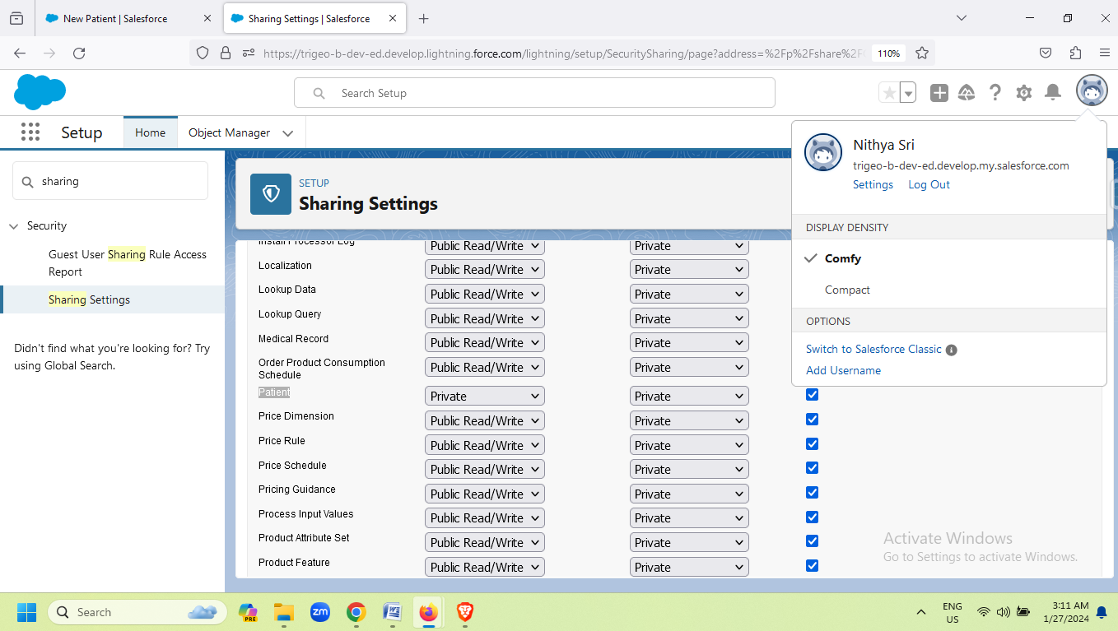

1. **written a code for Sharing Rule:**

public class Sharing_Patient_Object {

    Public Static void SharePatientRecords(){

        List<Patient__c> pts=[select id from Patient__c where Name='Naveen'];

        Patient__Share ptsshare= new Patient__Share();

       ptsshare.ParentId=pts[0].id;

       ptsshare.UserOrGroupId='0055i00000CXGe4AAH';

       ptsshare.AccessLevel='Read';

    insert ptsshare;

    }

}

**calling Method:**

Sharing_Patient_Object.SharePatientRecords();

**C.Image:**

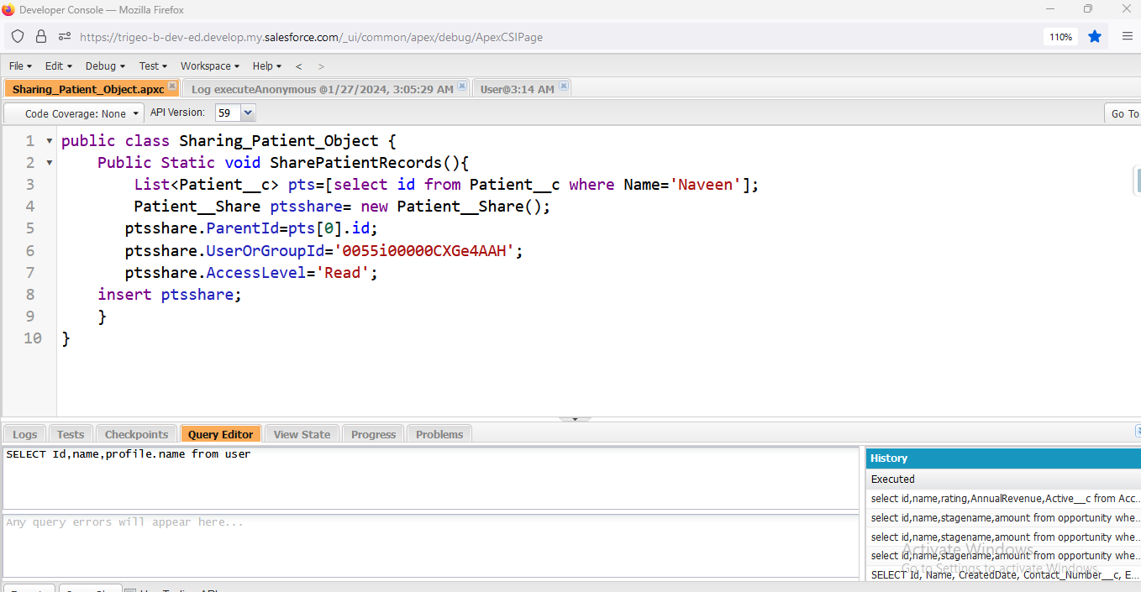

**D.Assigned Profile**

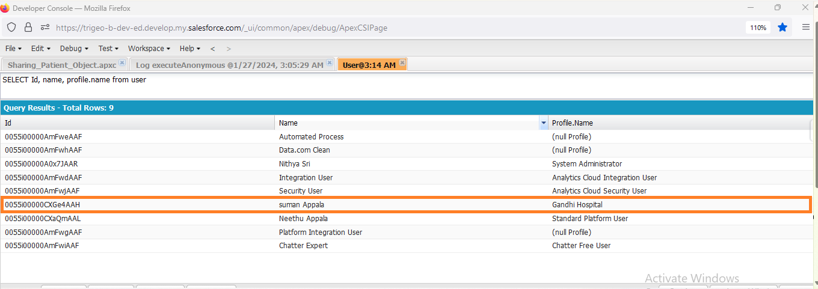

**E. The result of the code (owd is private but other user can be can be able see the record i.e Suman Appala)**

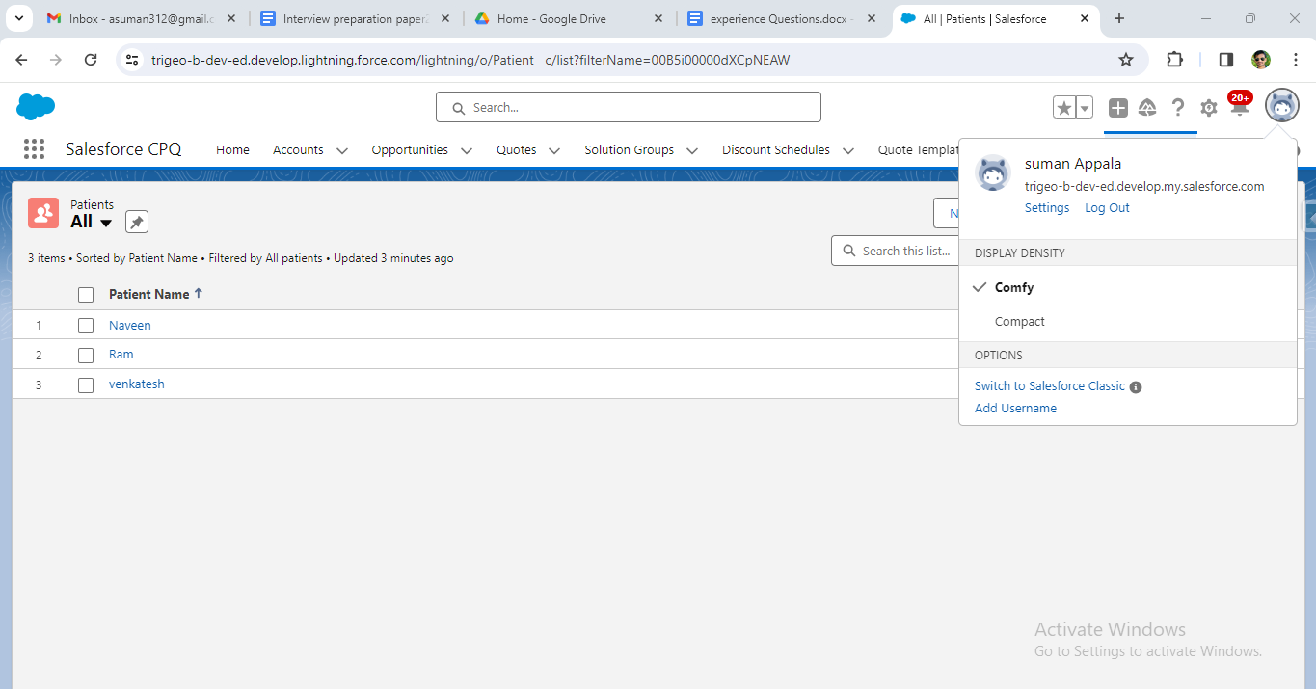

**4.4. Document Automation: Crafting Apex code to generate patient-related**

**documents like medical reports using templates.**

public class GenerateAndSave_Pdf {

    public static void savePdf(){

        string testdata='Stored as PDf';

        contentversion version= new contentversion();

        version.ContentLocation='s';

        version.Title='Testfile';

        version.PathOnClient=version.Title+'.pdf';

        version.VersionData=blob.topdf('testdata');

        insert version;

      id  conDocument=[select contentdocumentID from contentversion where id=:version.Id ].contentDocumentid;

        ContentDocumentLink Dlink=new contentDocumentLink();

        Dlink.contentDocumentId=conDocument;

        Dlink.LinkedEntityId='a1S5i000000dmO6EAI';

        Dlink.visibility='AllUsers';

        Dlink.ShareType='V';

        insert Dlink;

    }

}

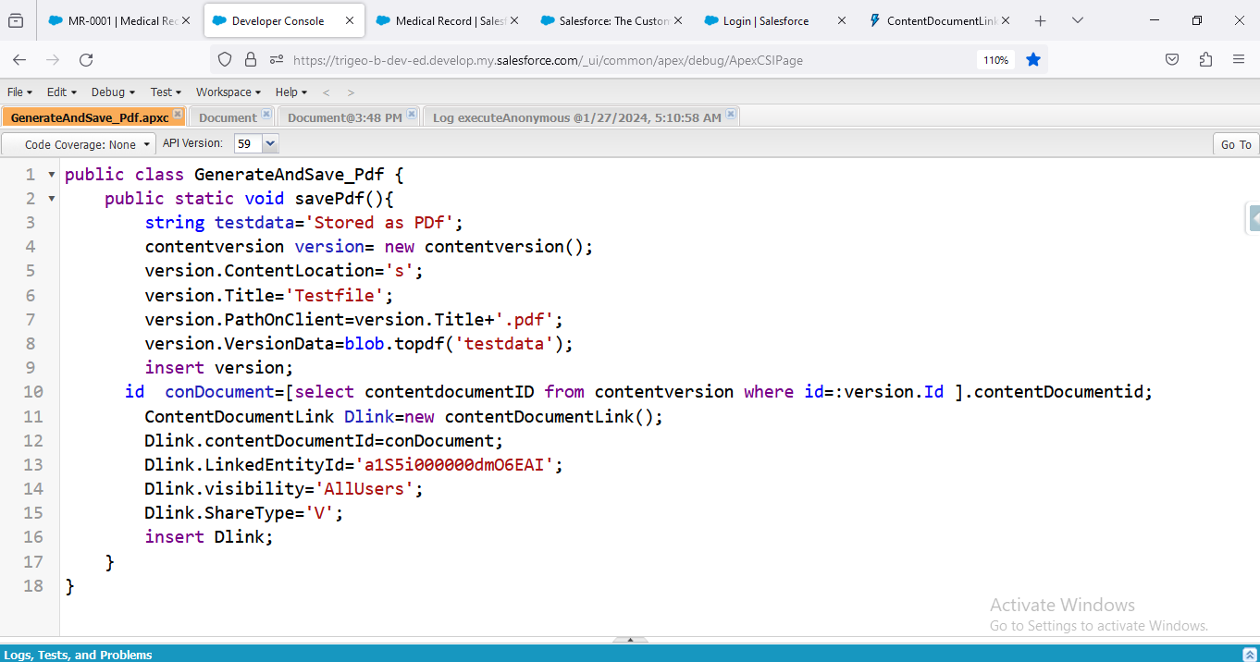

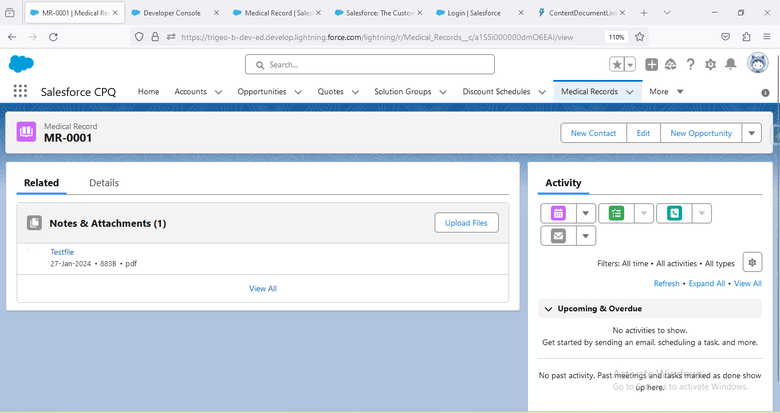

**Apex code:**

public class Email_TemplateHandlerr {

    // create  Medical_Records

    public static void createMedicalrecords(){

        list<Medical_Records__c>medlist=new List<Medical_Records__c>();

        for(integer count=1; count<2; count++){

            Medical_Records__c med=new Medical_Records__c();

            med.Patient_Address__c='Hyderabad';

            med.Patient_Admit_Date__c=Date.today().addDays(-12);

            med.Patient_Discharge_Date__c=Date.today().addDays(+30);

            med.Patient_Name__c='Ram';

            med.Email__c='asuman312@gmail.com';

            medlist.add(med);

        }

        if(!medlist.isempty()){

           database.insert(medlist,false);

            sendnotification(medlist);

        }

    }

    public static void sendnotification(list<Medical_Records__c> mdlist){

        if(!mdlist.isempty()){

             list<messaging.singleemailmessage> emaillist=new list<messaging.singleemailmessage>();

            for(Medical_Records__c medrec:mdlist){

                messaging.singleemailmessage email=new messaging.singleemailmessage();

                //set to address

                string[] toaddress=new string[]{medrec.Email__c};

                    email.settoaddresses(toaddress);

                // setreplyto

               email.setreplyto('supportGandhiHospital12@gmail.com');

                // sender displayname

                email.setsenderdisplayname('GandhiMedicalteam');

                // subject

               string subject='Your Medical Reports are out Mr.';

                email.setsubject(subject);

                string Content='Dear,'+medrec.Patient_Name__c+'<br/><br/>'+

                      'Use this form to request medical information from your physician <br/><br/>'+

                      'Your Information:<br/><br/>'+

                      '<br/>Patient Name:'+medrec.Patient_Name__c+

                      '<br/>Patient AdmitDate:'+medrec.Patient_Admit_Date__c+

                      '<br/>Patient Discharge Date:'+medrec.Patient_Discharge_Date__c+

                      '<br/>Patient Email Id:'+medrec.Email__c+

                      '<br/>*******this is System generated email********'+

                      'Thank you,<br/>'+

                      'Gandhi Hospital Team <br/>'+

                      'DHO.';

                email.setHtmlbody(Content);

             messaging.emailfileattachment attach=new messaging.emailfileattachment();

                attach.setfilename(+medrec.Patient_Name__c+'.pdf');

                attach.setcontenttype('Application/pdf');

                attach.body=blob.topdf(content);

                list<messaging.emailfileattachment> attachlist=new list<messaging.emailfileattachment>();

                attachlist.add(attach);

                Email.setfileattachments(attachlist);

                emaillist.add(email);

            }

            if(!emaillist.isEmpty()){

               messaging.sendemailresult[] result=messaging.sendemail(emaillist);

            }

        }

    }

}

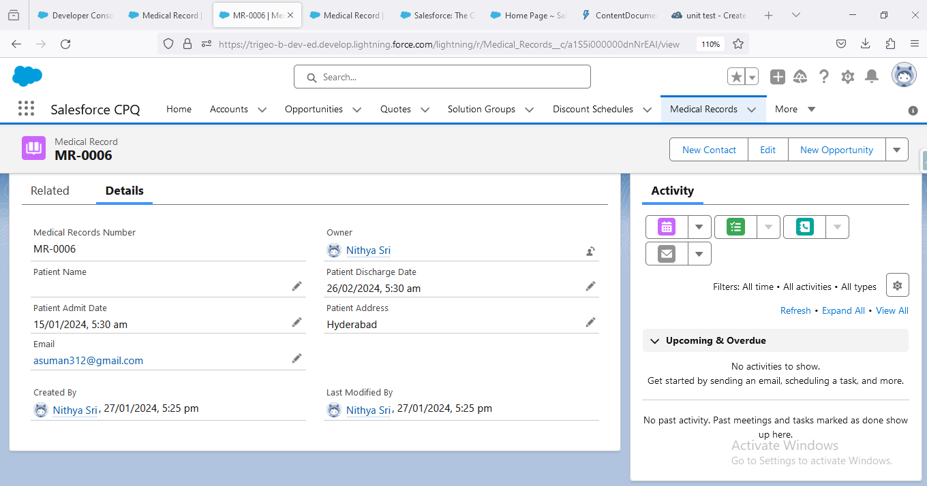

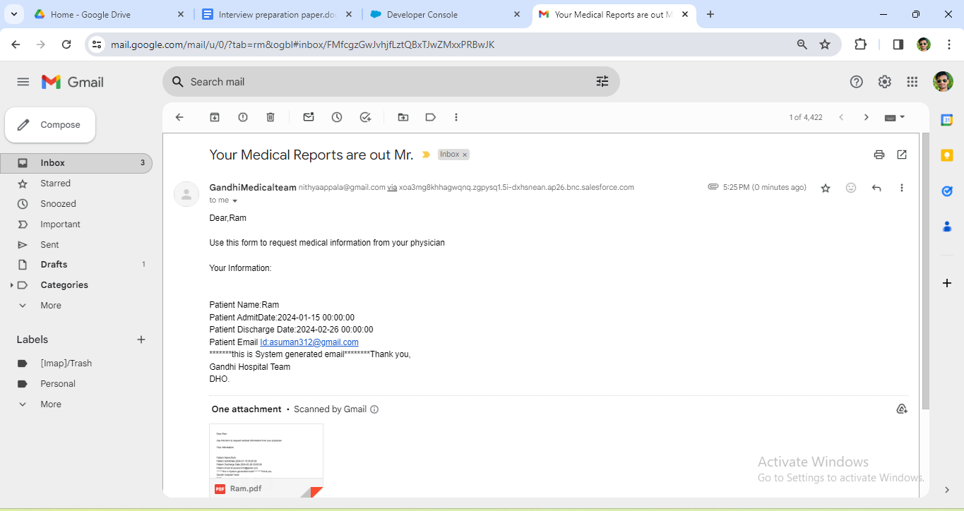

**4.5. Real-time Updates: Creating triggers or processes to maintain data**

**consistency with real-time updates.**

1. **Create a Trigger on medical record Object, to make the  Patient admit date ,Email and Discharge date  should be Mandatory upon creating or updating a medical  Record.**

**Trigger code:**

**trigger medicalrecordsTrigger on Medical_Records__c (before insert, before update) {**

**// Before Insert Or Before Update**

**if ((Trigger.isInsert || Trigger.isUpdate) && Trigger.isBefore) {**

**for (Medical_Records__c mdrecords : Trigger.New) {**

**if (mdrecords.Email__c == null || mdrecords.Email__c =='') {**

**mdrecords.addError('Please Enter the Email Id.');**

**} else if (mdrecords.Patient_Admit_Date__c == null) {**

**mdrecords.addError('Please Enter the Admission Date.');**

**} else if (mdrecords.Patient_Discharge_Date__c == null) {**

**mdrecords.addError('Please Enter the Discharge Date');**

**}**

**}**

**}**

**}**

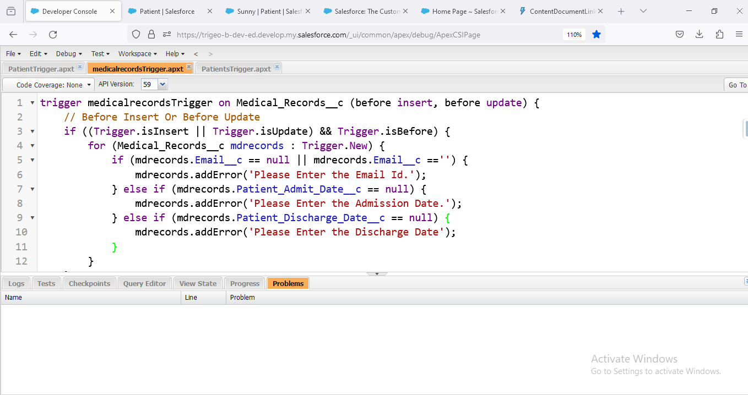

**Patient Admit date:**

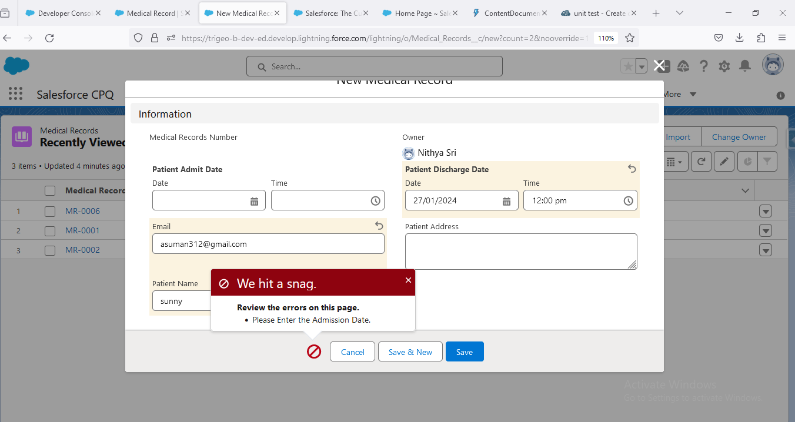

**discharge date:**

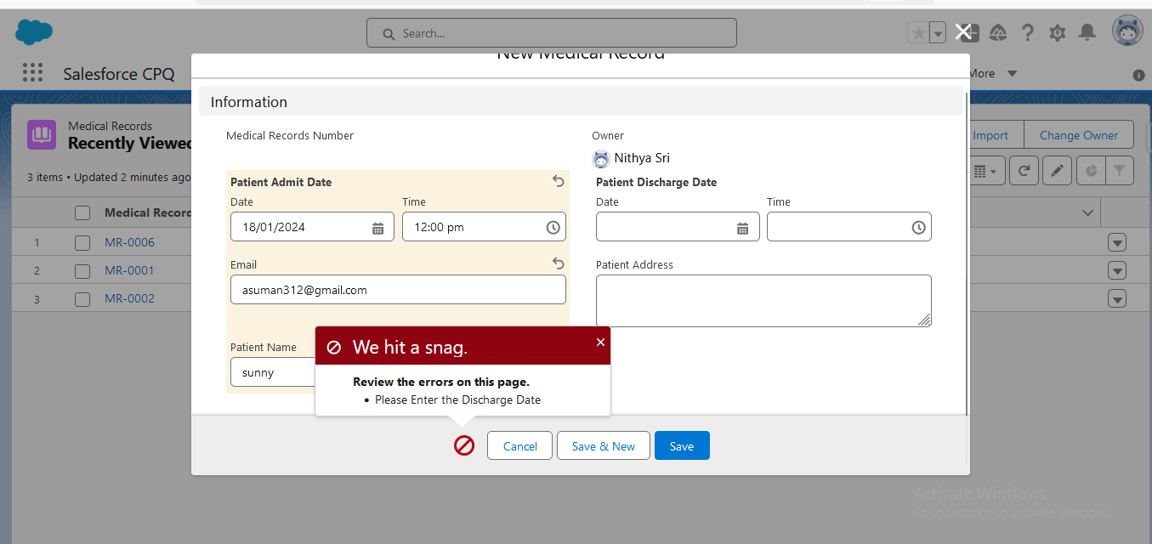

**Email:**

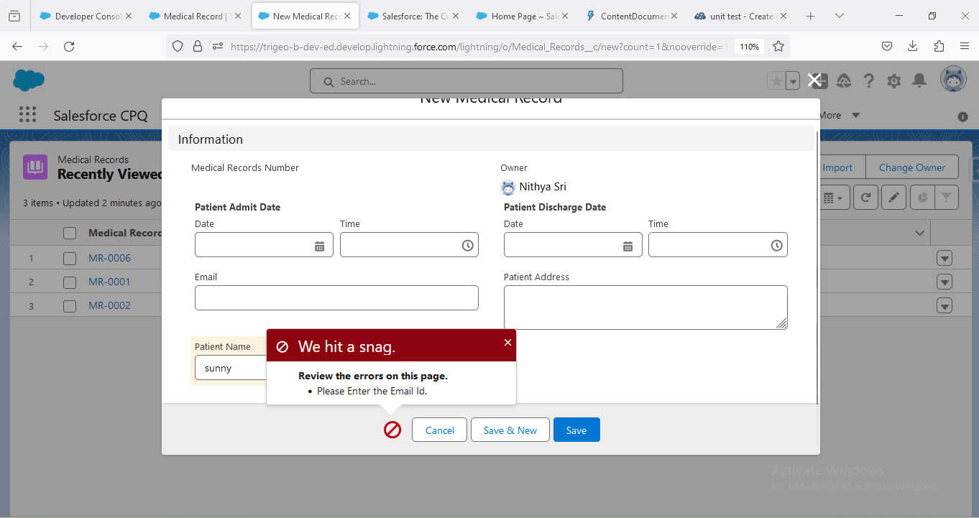

### Write a trigger on Patient , when an record is inserted in object , automatically address should populate into the Temporary  address.

**Trigger code:**

trigger PatientsTrigger on Patient__c (before insert) {

    for(Patient__c pat: Trigger.new){

        if(pat.Address__c!=null ){

            pat.Tempo__c= pat.Address__c;

        }

    }

}

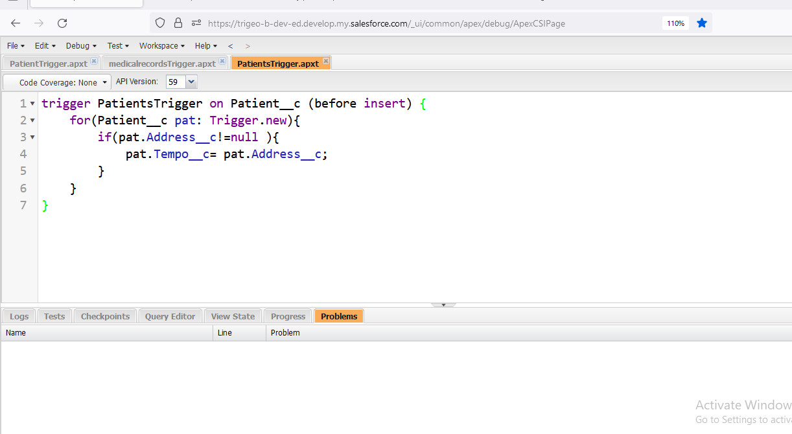

**checking Output:**

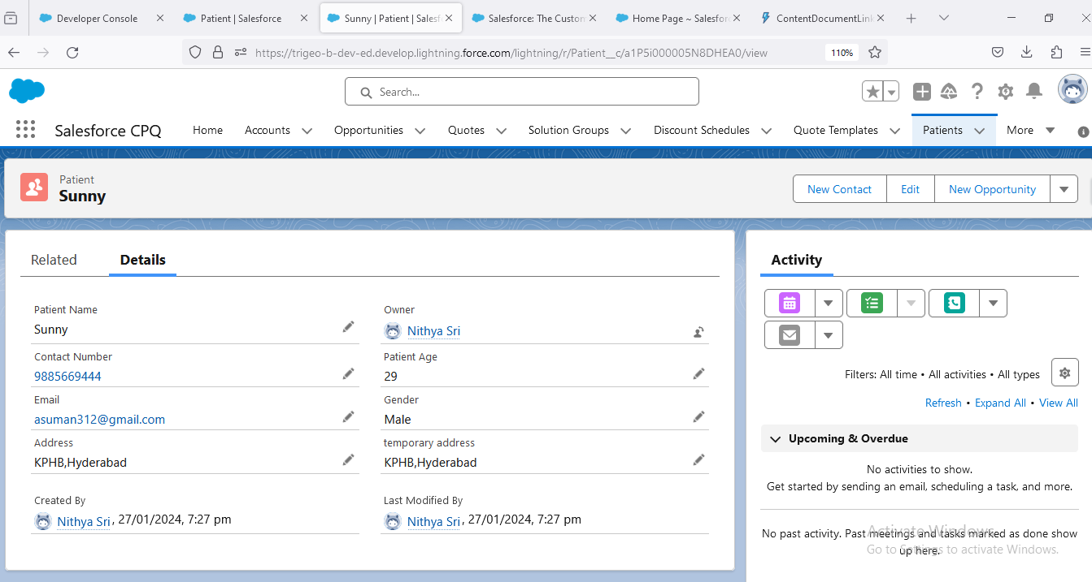

**write a trigger on Patient object Only the system administrator can delete the Patient  record**

trigger Patients_Trigger on Patient__c (before delete) {

       set<Id> Patientfor = new set<Id>();

     for(Patient__c Pat : Trigger.Old){

        Patientfor.add(Pat.Id);

         if(Patientfor.size()>0){

             Id UID = userinfo.getUserId();

        User Us = [SELECT Id,Profile.Name FROM User WHERE Id=:UID];

             if(Us.Profile.Name!= 'System Administrator'){

            Trigger.Old[0].Id.addError('You Cannot delete Patient record');

        }

         }

     }

}

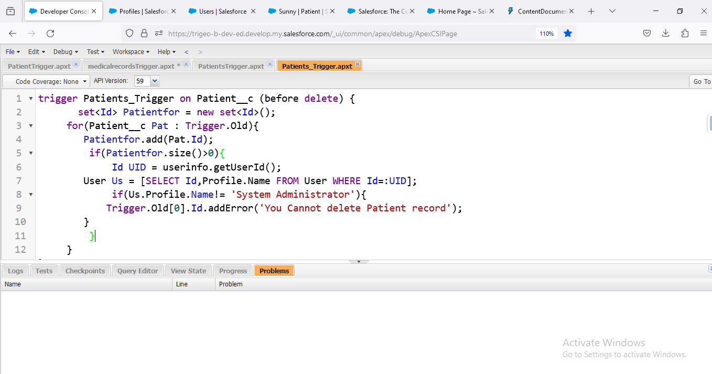

**Scenario 3: HTML, CSS: Using HTML, CSS create an animated underline effect**

**when the user hovers over the text.**

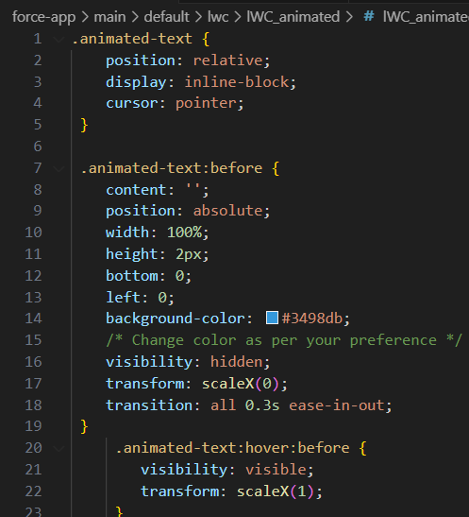

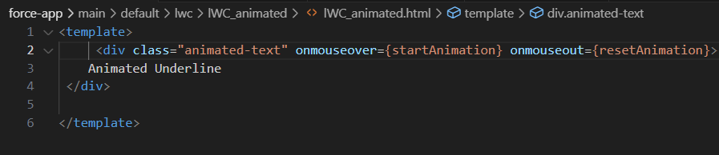

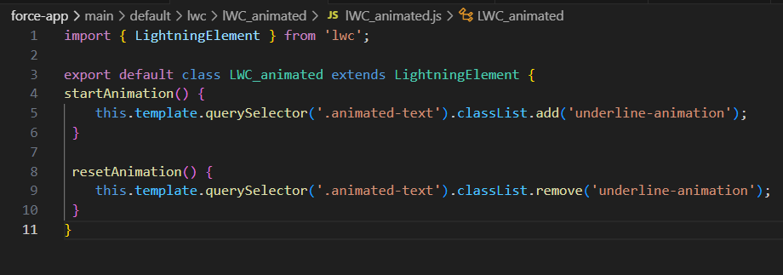

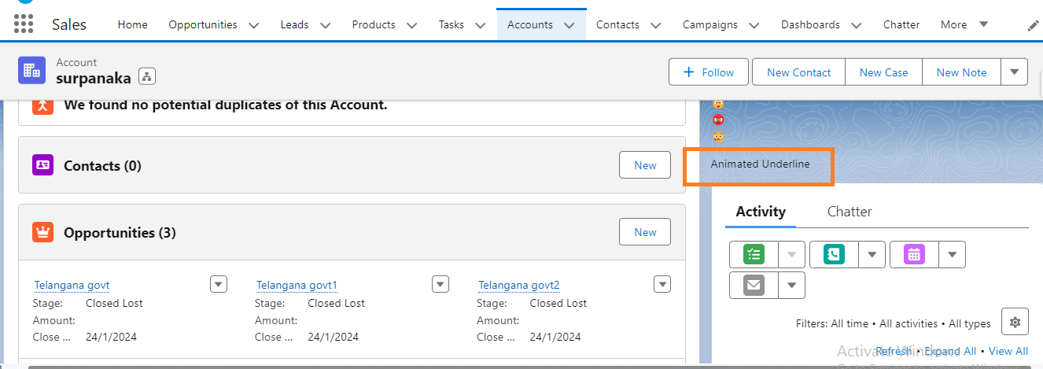

### #################################

### Interview preparation- 2

**1. General Questions**

**1. Tell me about yourself?**

Thanks for giving opportunity to introduce my self,This is suman appala I completed my graduation in 2012 in kakatiya university warangal. I can utilize my problem-solving abilities and collaborate with teams to achieve common goals. I'm known for my dedication to continuous learning and my ability to effectively communicate complex ideas

**2. Explain your IT and Salesforce Journey?**

I'm suman Appala with 8 years of experience which include 4.1 years  in developing and designing the custom logics on the Salesforce platform, Salesforce CRM, I have also been involved in designing and implementing data model like creating objects fields and relationship to optimize the data management and enhancement reporting capabilities, I have hands on experience with apex programming language apex triggers, test classes, and also this synchronous process that is creating the batch classes and also lightning development I have knowledge on Process automation tool, that is process builder workflow rules Flow Builder, I have experienced with SQL and sosl queries for data retrieval and also data manipulation. So, this is all about my professional experience.

**3. Which clouds, you have worked in Salesforce?**

sales and service cloud

**4. What is your Notice Period?**

30 days

**5. Are you a contract or permanent employee?**

Permanent company staff

**6. What is your current CTC?**

7 LPA

**7. Is your Current CTC Fixed or Variable?**

fixed

**8. What is your monthly take-home?**

51000

**9. What is your Expected Salary?**

my expecting salary is 12LPA

**10. Why are you changing the Organization?**

To accepting new challengings

**2. Project Questions**

**2.1. How salesforce helping you in your day to day ?**

Going through the usecase documents, understanding and analyzing the requirements

**2.2. How many Salesforce Projects you have worked on?**

4

**2.3. Explain your current Salesforce Project Descriptions from end to end?**

Coupons.com is being tracked as one of the 30 companies in China, Europe, and the United States. Clients include consumer packaged goods brands, restaurant, toy and entertainment companies, as well as general retailers. Coupons.com also has an affiliate marketing program called Brand caster which is aimed at long tail users

**2.4. Are you helping Freshers in your Project?**

Yes

**2.5. What is your Role and Responsibilities in your current Project?**

Played the role of Salesforce.com Administrator and Developer.  Sales force Administrators configure and manage Sales and Service Cloud applications.  Utilizing various tools to load and clean data, configuring custom and standard objects and providing support for App Exchange integration with accounting.  Involved in gathering and documenting requirements from users.  Developed Salesforce.com custom application using Apex classes, Apex triggers.  Developed various Custom Objects, Reports, Tabs, Components and Visual force Pages and Controllers for different user profiles based on the need in the organization.  Created page layouts, validation rules, email templates, workflows and approval processes as per the Business requirements.  Creating and managing profiles, roles, visibility settings.  Performed user & administration training sessions for clients to utilize Sales force and respective programs.

**2.6. What are your day-to-day activities in your current Project?**

Going through the usecase documents, understanding and analyzing the requirements

**2.7. Are you part you part of a solution?**

**2.8. Which clients and client locations you have worked for?**

Quotient (Coupons.com), Salt Lake City, Utah, USA

**2.9. What is your current/recent work in your Salesforce Project?**

Coupons.com is being tracked as one of the 30 companies in China, Europe, and the United States. Clients include consumer packaged goods brands, restaurant, toy and entertainment companies, as well as general retailers. Coupons.com also has an affiliate marketing program called Brand caster which is aimed at long tail users

**2.10. What are your strengths and weaknesses while working on Salesforce Projects?**

My greatest strength is to accepting the new tasks and my weakness is I will put more concentration on single work at a time

**2.11. What are the different challenges you faced while working on Salesforce Projects?**

**2.12. What is your team size?**

20

**3. Admin Questions**

**3.1. What is a recent admin scenario, you have worked on?**

Customization, configuration on Data modeling

**3.2. What are the Functionalities you have worked in Admin?**

Resolve user support tickets, Identify and gather requirements from users and stakeholders,users and license management roles,profile,permission sets

**3.3. Validates that the Phone number begins with a plus sign (+) for the country code. Note that this validation rule conflicts with the ten-digit rule**

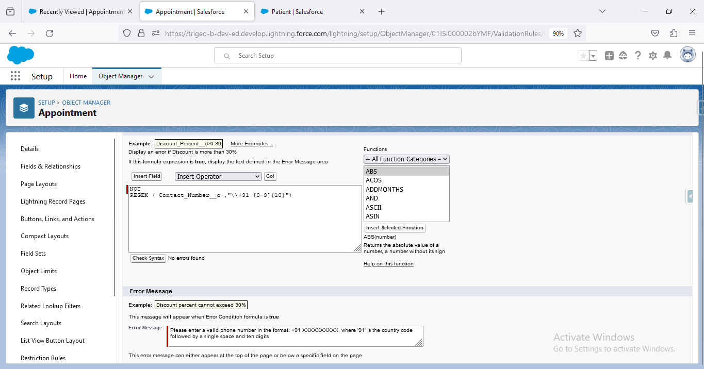

**NOT**

**REGEX ( Contact_Number__c ,"\\+91 [0-9]{10}")**

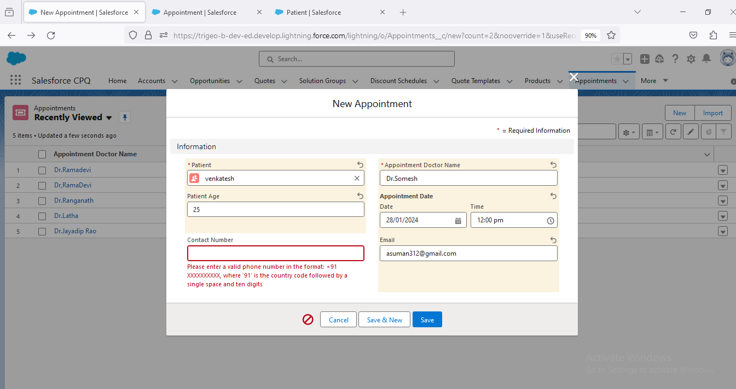

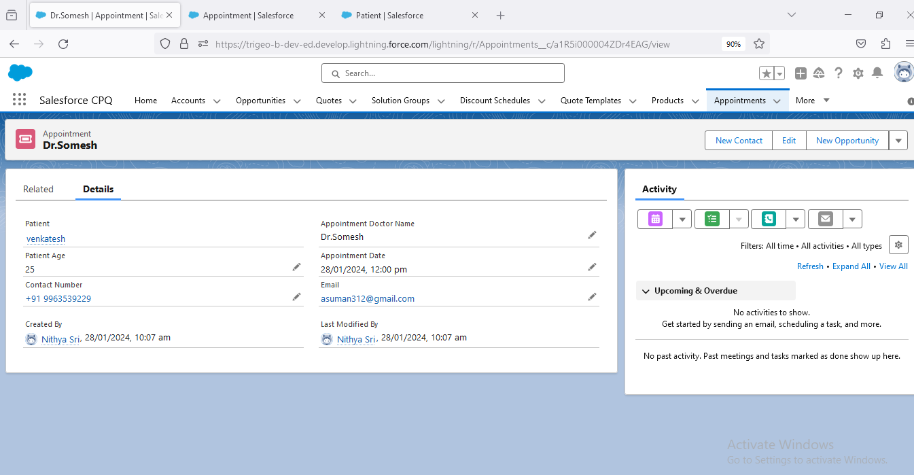

**3.4. Validate that the custom date field contains a date within the current month and year.**

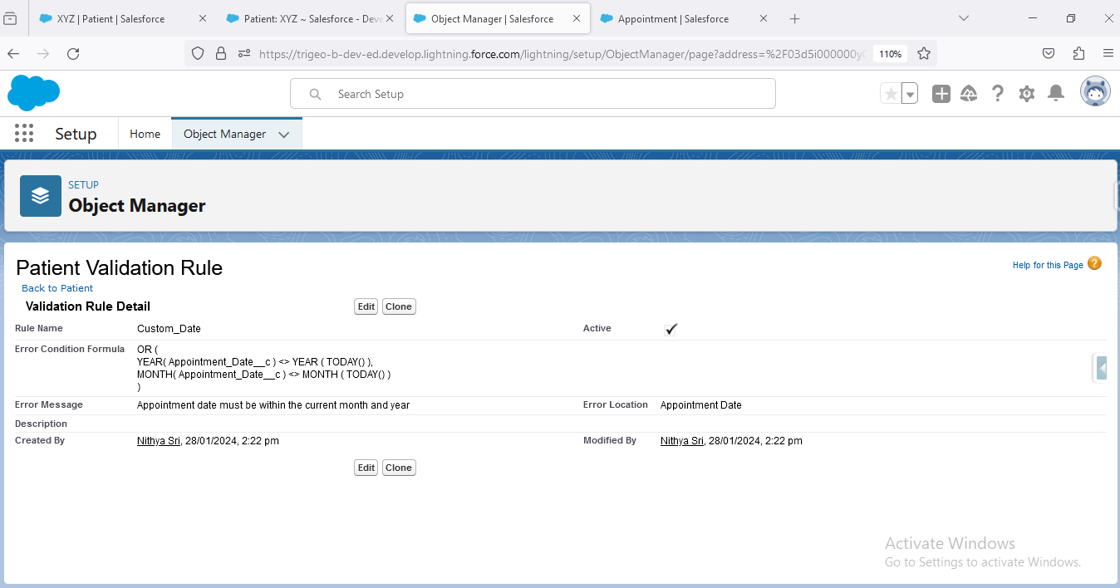

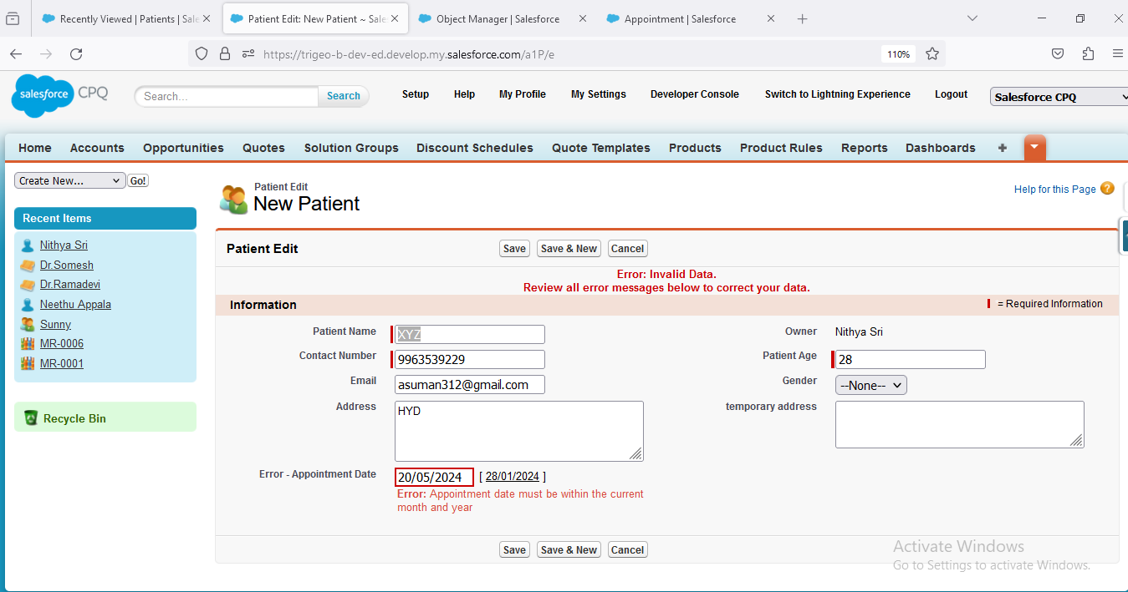

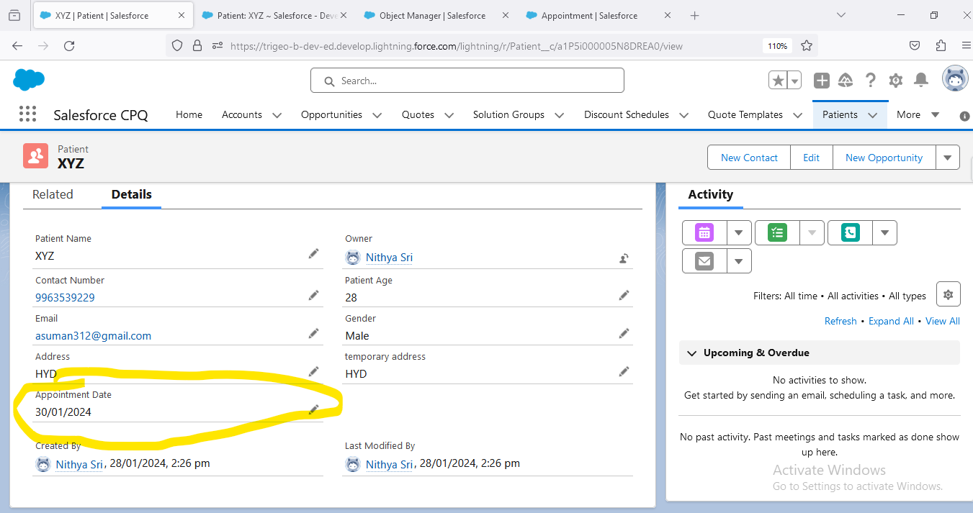

**3.5. Prevent Sales reps from changing the opportunity stage “backward” to specific values**

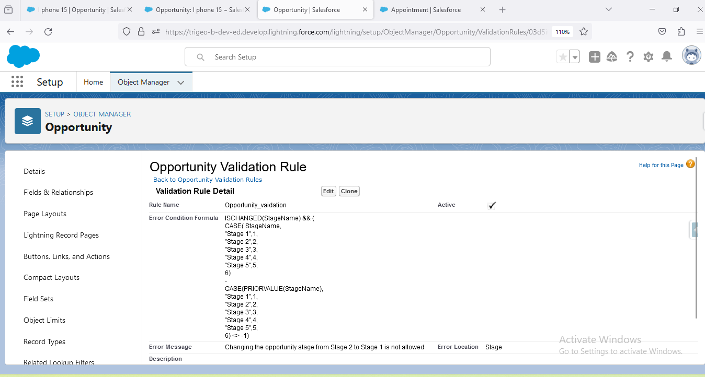

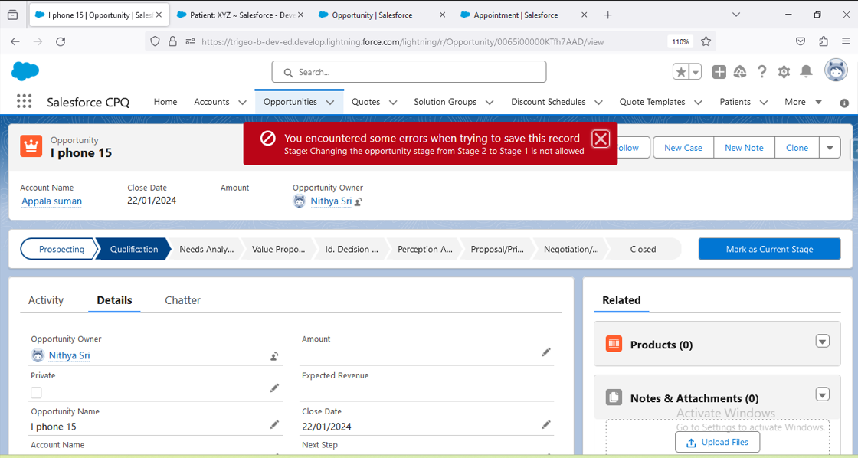

**4. Apex, SOQL, SOSL Questions**

**4.1. What is a recent APEX, SOQL, SOSL scenarios, you have worked on?**

In my recent project, we are tasked with implementing a custom Salesforce solution for My client. I extensively utilized APEX, SOQL, and SOSL throughout the development process. One of was when we needed to optimize a complex data retrieval operation. I leveraged SOQL to efficiently query and retrieve the required data from Salesforce objects. Additionally, SOSL played a crucial role when we had to perform a full-text search across multiple objects to gather relevant information.

**4.2. What are the Functionalities you have worked in APEX, SOQL, SOSL?**

Batch Apex,Scheduling jobs,Future method,FlexQueue,Queueable interface,DML with Apex,implementing the Complex Queries by usingSOQL with conditions and Aggregating with Sum,count,min,max,Apex code execution debug performance

**4.3. Complex Validation Logic: Extending validation rules beyond standard Salesforce functionalities using Apex code.**

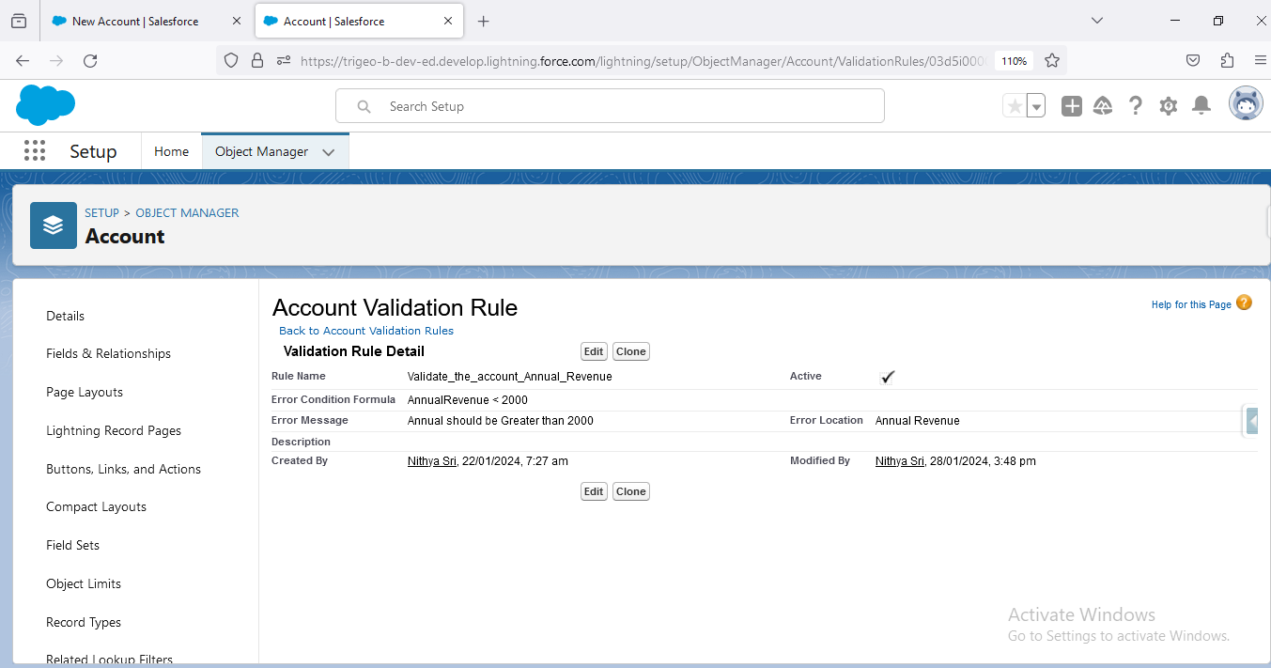

trigger Account_Trigger on Account (before delete) {

for(Account acc:trigger.old){

    if(acc.AnnualRevenue > 2000){

       acc.adderror(' Cannot delete Account because Annual revenue is Greater Than 2000');

    }

 }

}

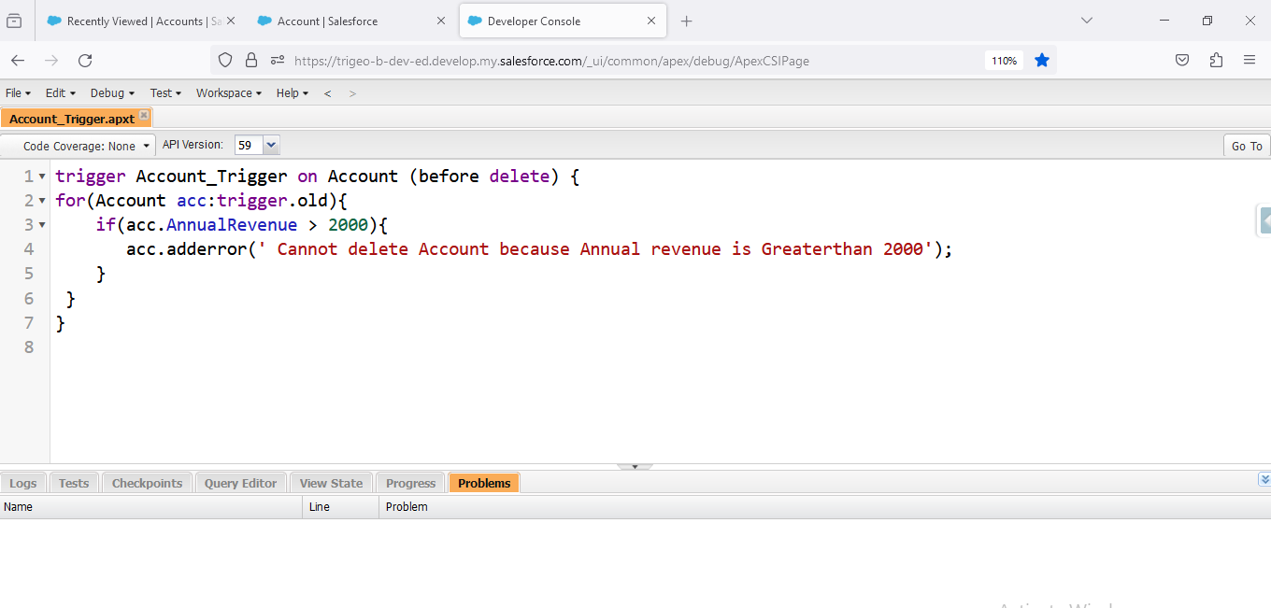

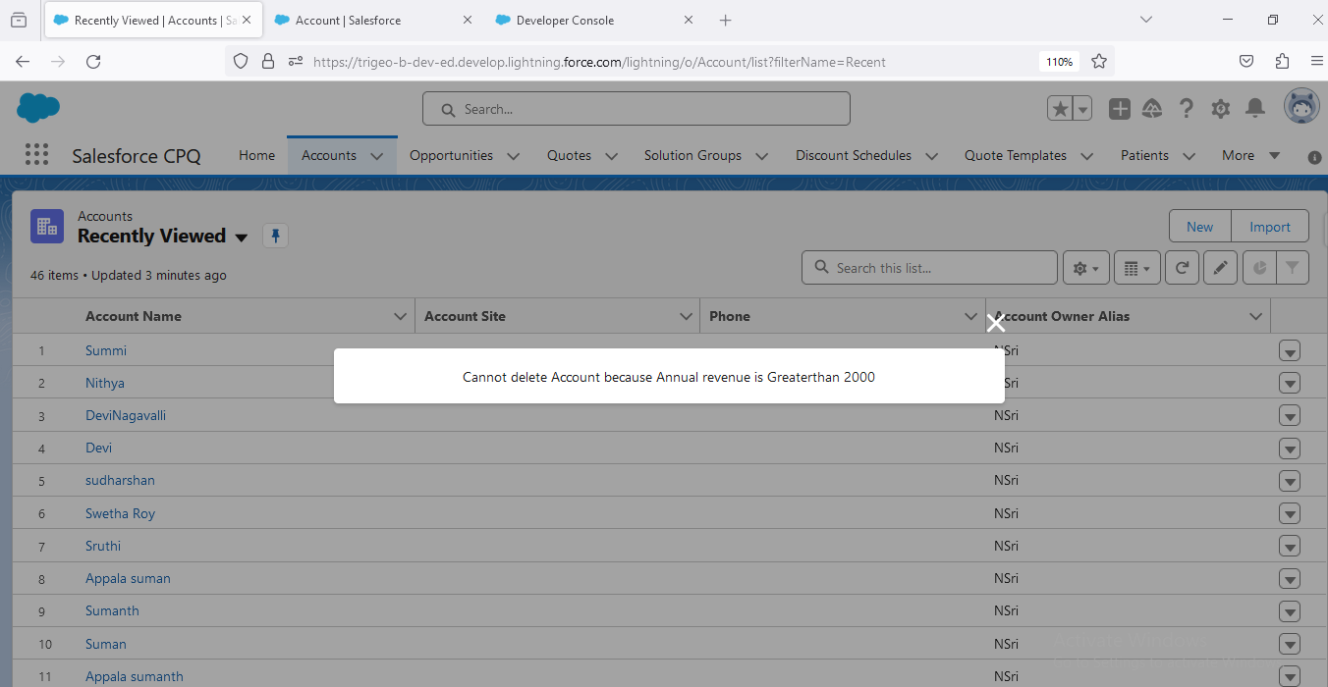

**4.4. Bulk Data Handling: Writing scalable Apex classes for efficient handling of large datasets during migrations.**

global class ApexBulk_DataHandling implements Database.Batchable<sobject> {

global database.querylocator start(database.batchablecontext bcontext){

       string query='select id,name,rating,AnnualRevenue,Active__c,Industry,Phone,Type from Account';

        return database.getquerylocator(query);

    }

    global void execute(database.batchablecontext bcontex, list<sobject> reclist){

        if(!reclist.isempty()){

            list<account>acclist=new list<account>();

            for(sobject sobj:reclist){

                account accrecord= (account)sobj;

                accrecord.Phone='9963539229';

                accrecord.Type='Customer-Direct';

                accrecord.AnnualRevenue=2500000;

                accrecord.Active__c='yes';

                accrecord.Rating='cold';

                accrecord.Industry='Banking';

                acclist.add(accrecord);

            }

            if(!acclist.isempty()){

                database.update(acclist,false);

            }

        }

    }

    global void finish(database.batchablecontext bcontext){

      AsyncApexJob jobdetails=[SELECT Id, JobType, Status, TotalJobItems,NumberOfErrors,CompletedDate, MethodName FROM AsyncApexJob where id=:bcontext.getjobid()];

                 system.debug('job details---->'+jobdetails);

    }

}

**Calling Method:**

ApexBulk_DataHandling DataHandling= new ApexBulk_DataHandling();

Database.ExecuteBatch(DataHandling,20);

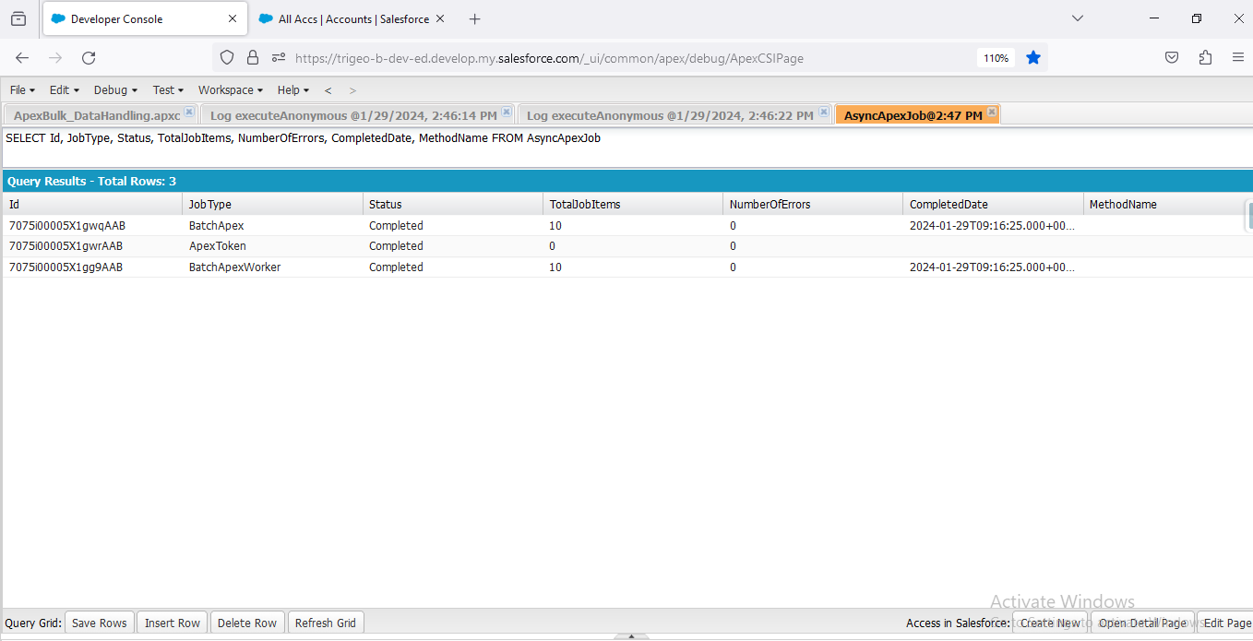

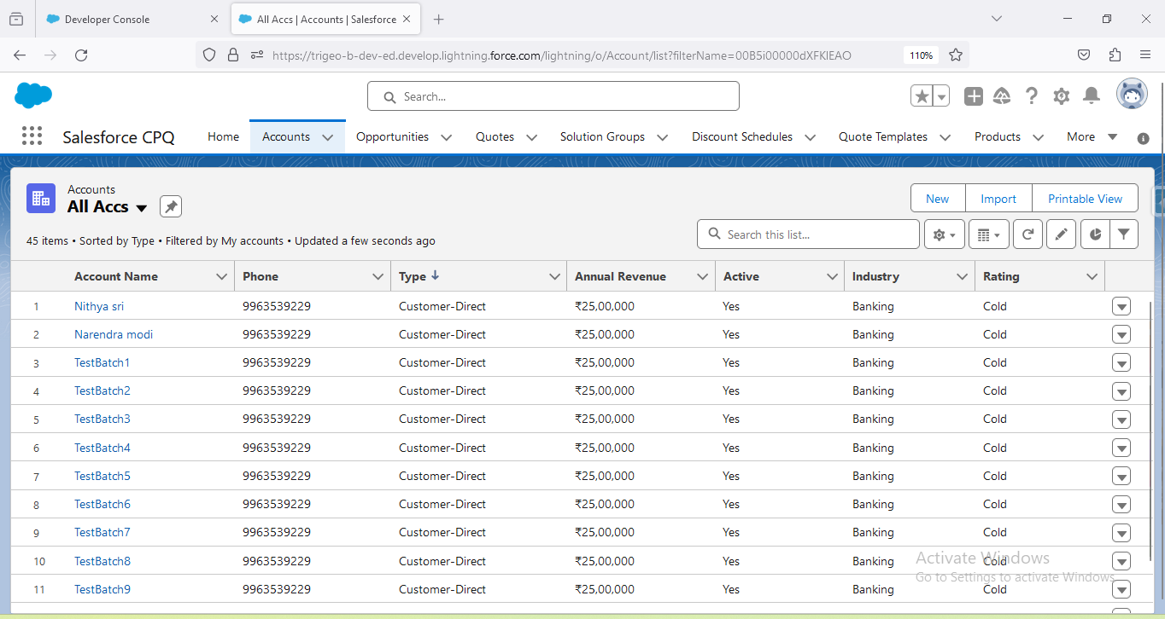

**4.5. Scheduled Processes: Enabling automation via Apex schedulable classes for routine tasks like data backups.**

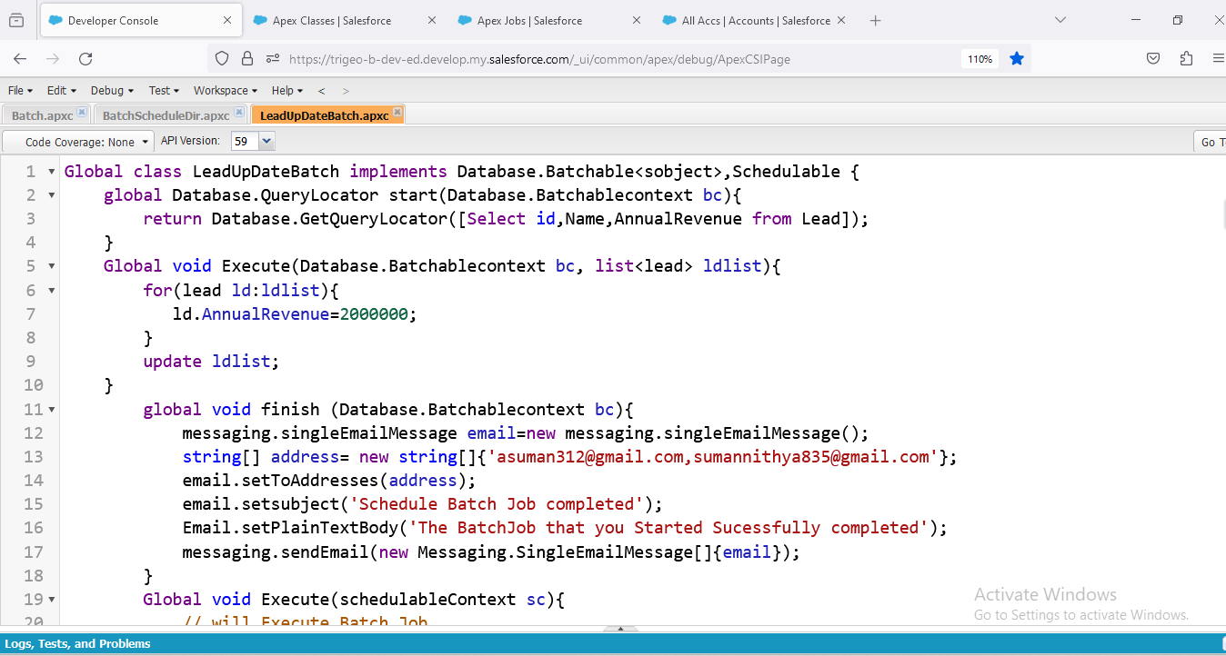

Global class LeadUpDateBatch implements Database.Batchable<sobject>,Schedulable {

    global Database.QueryLocator start(Database.Batchablecontext bc){

        return Database.GetQueryLocator([Select id,Name,AnnualRevenue from Lead]);

    }

    Global void Execute(Database.Batchablecontext bc, list<lead> ldlist){

        for(lead ld:ldlist){

           ld.AnnualRevenue=2000000;

        }

        update ldlist;

    }

        global void finish (Database.Batchablecontext bc){

            messaging.singleEmailMessage email=new messaging.singleEmailMessage();

            string[] address= new string[]{'asuman312@gmail.com,sumannithya835@gmail.com'};

            email.setToAddresses(address);

            email.setsubject('Schedule Batch Job completed');

            Email.setPlainTextBody('The BatchJob that you Started Sucessfully completed');

            messaging.sendEmail(new Messaging.SingleEmailMessage[]{email});

        }

        Global void Execute(schedulableContext sc){

            // will Execute Batch Job

            LeadUpDateBatch leadupdate= new LeadUpdateBatch();

            Database.ExecuteBatch(leadupdate);

        }

    }

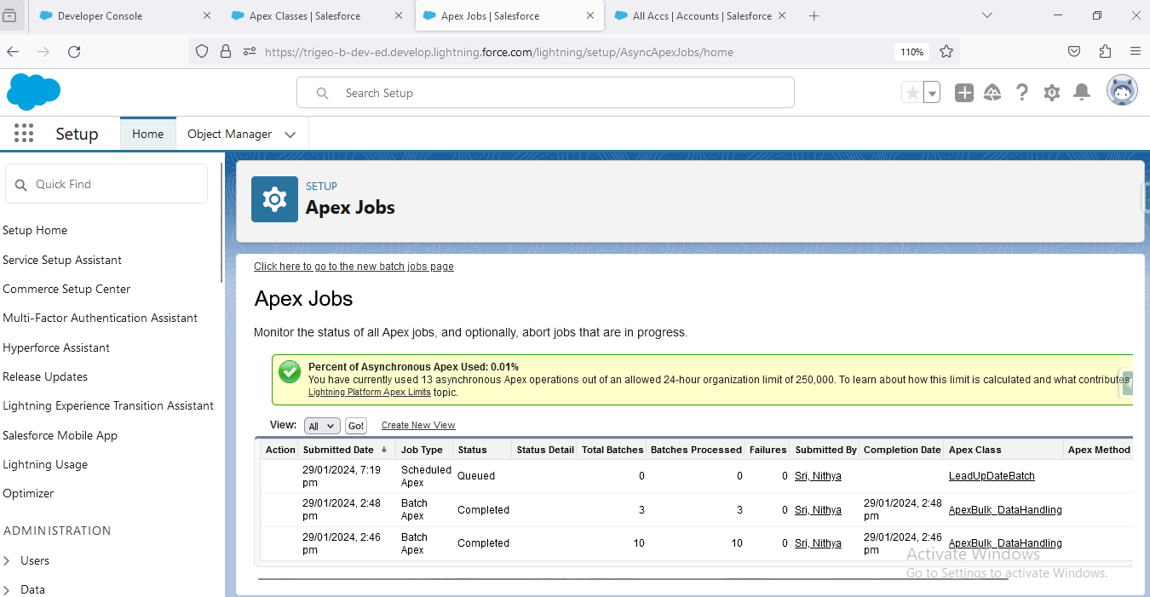

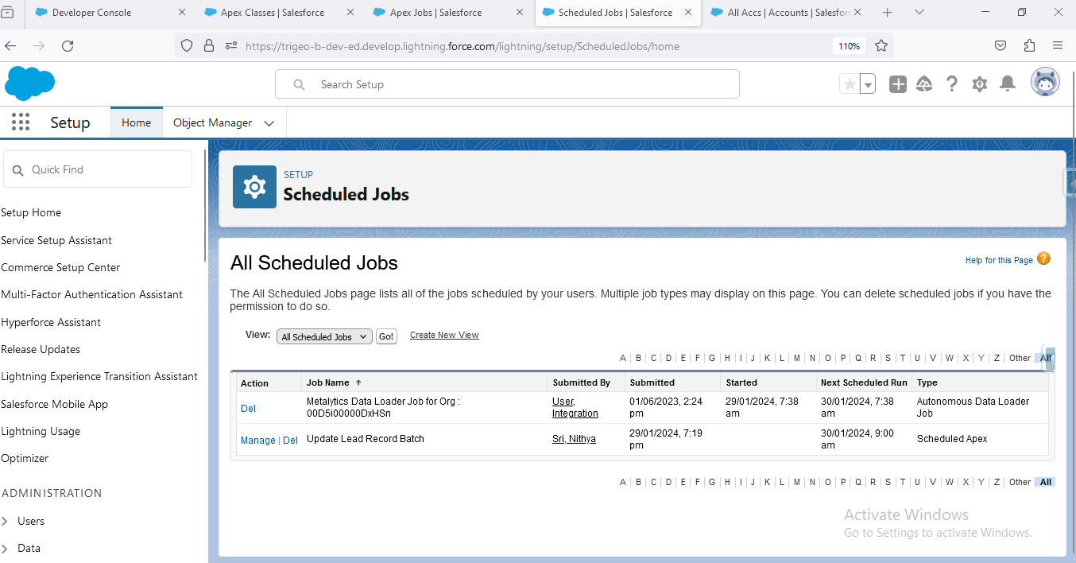

**5. Lightning Web Components Questions**

**5.1. How many LWC components, you have created?**

**5.2. What is a recent Lightning Web Components scenarios, you have worked on?**

**5.3. What are the Functionalities you have worked in Lightning Web Components?**

**5.4. Using HTML, CSS create an emojis and capture the answer and display the answers below**

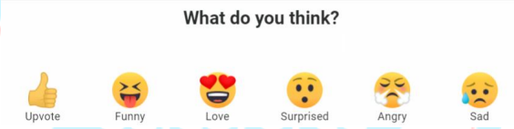

**HTML**

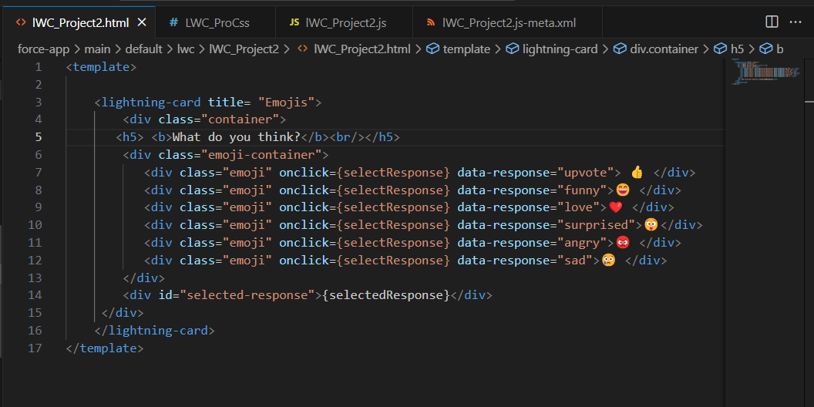

**JS**

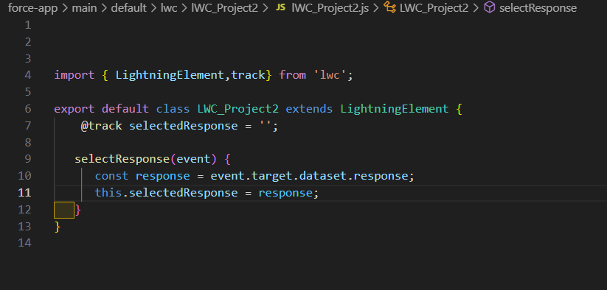

**CSS**

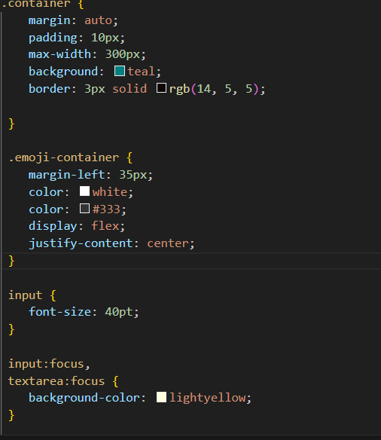

**Meta XML**

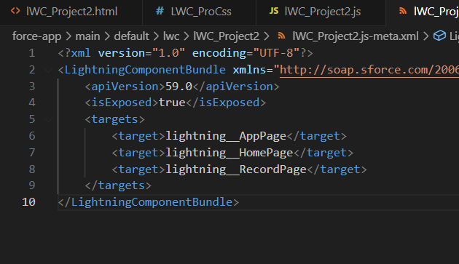

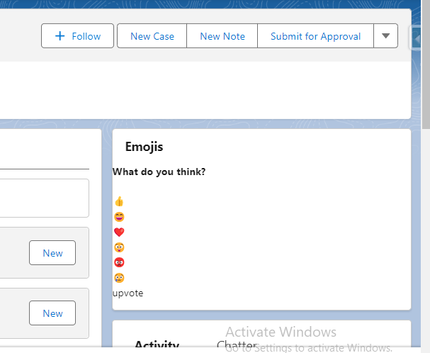

**5.5. Implement a Registration form and validate the password**

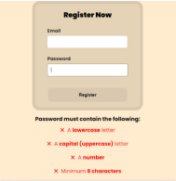

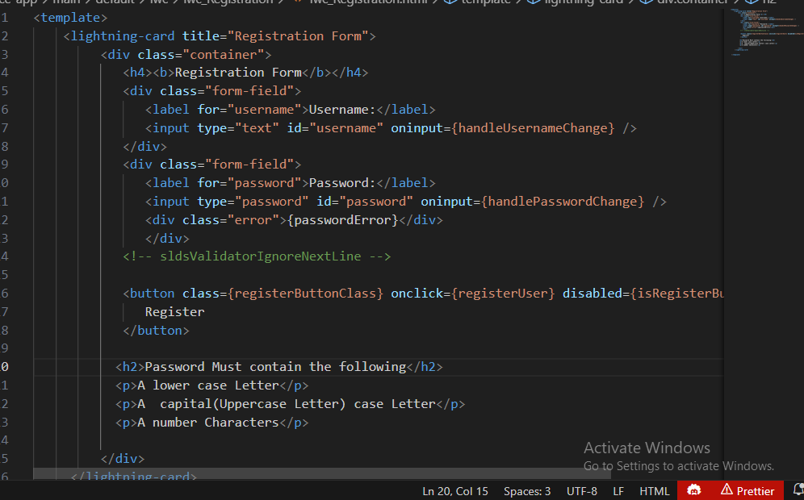

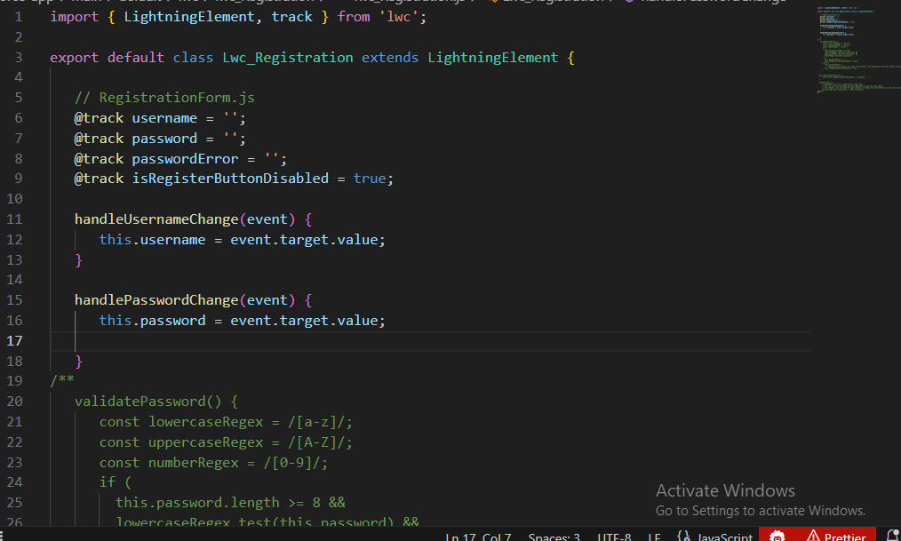

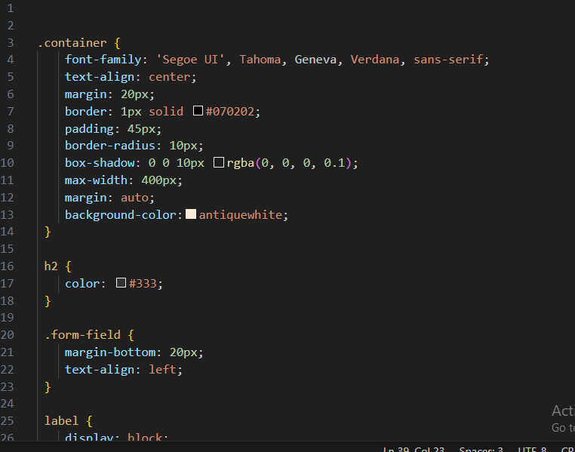

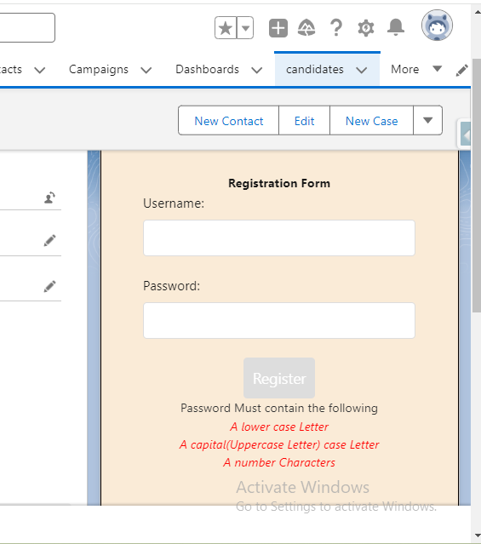

**####################################################################**

### Interview preparation- 3

v